

extra Comprehension text  **Grade 5**

Name ………………… Date: / /2023

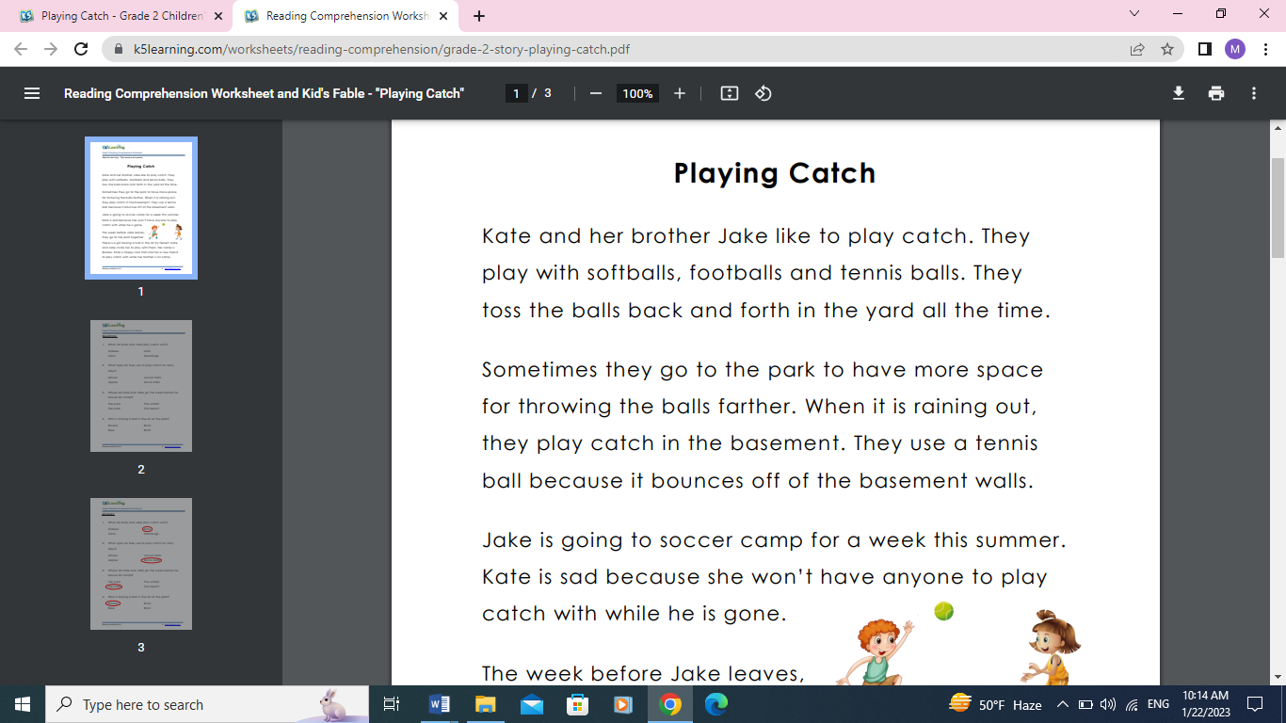

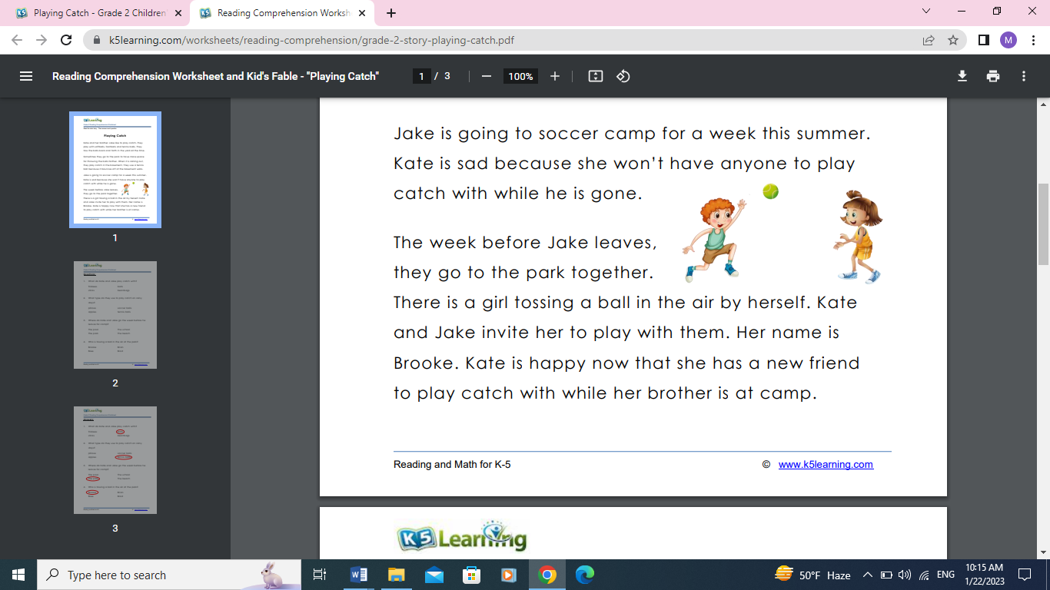

Teacher: Mirna Nawaf Al-Sahawneh.