

extra Comprehension text  **Grade 6**

Name ………………… Date: / /2023

The New Principal

Macy and her family had a great time at the school fair. There were games, cotton candy, and even a dunk tank. The fair had prizes, and Macy won the best prize. She got to be the principal for a day! On Monday morning, Macy’s principal let her sit in the principal’s chair at her big desk. Macy spun around on the chair. This was fun already.

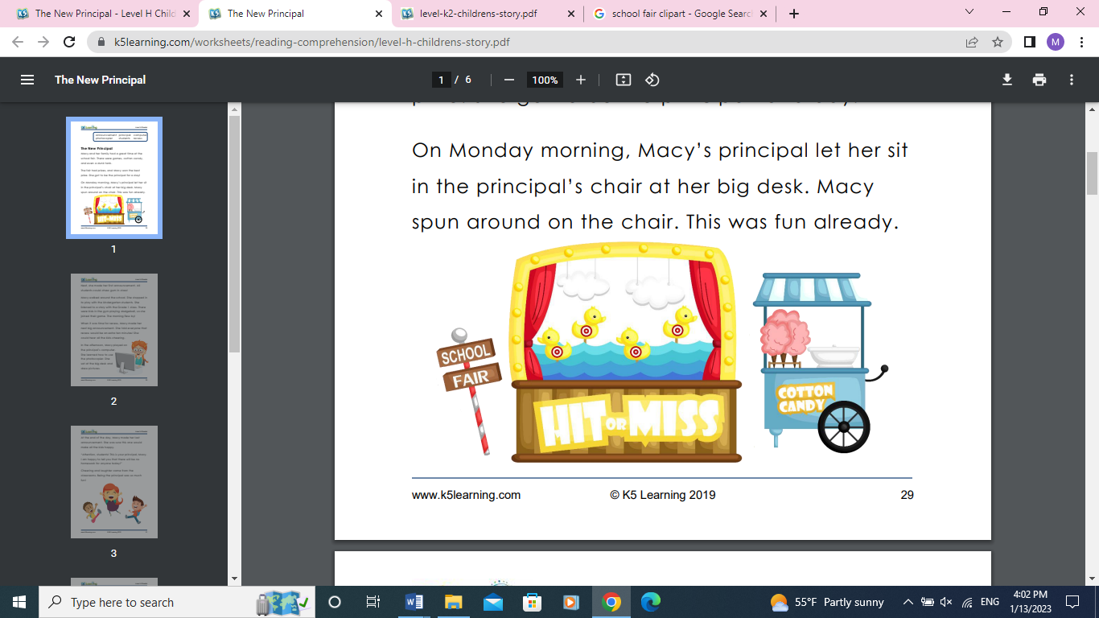

Next, she made her first announcement. All students could chew gum in class! Macy walked around the school. She stopped in to play with the kindergarten students. She listened to a story with the Grade 1 class. There were kids in the gym playing dodgeball, so she joined their game. The morning flew by! When it was time for recess, Macy made her next big announcement. She told everyone that recess would be an extra ten minutes! She could hear all the kids cheering. In the afternoon, Macy

played on the principal’s computer. She learned how to use the photocopier. She sat at the big desk and drew pictures.

At the end of the day, Macy made her last announcement. She was sure

this one would make all the kids happy. “Attention, students! This is your principal, Macy. I am happy to tell you that there will be no homework for anyone today!” Cheering and laughter came from the classrooms. Being the principal was so much fun!

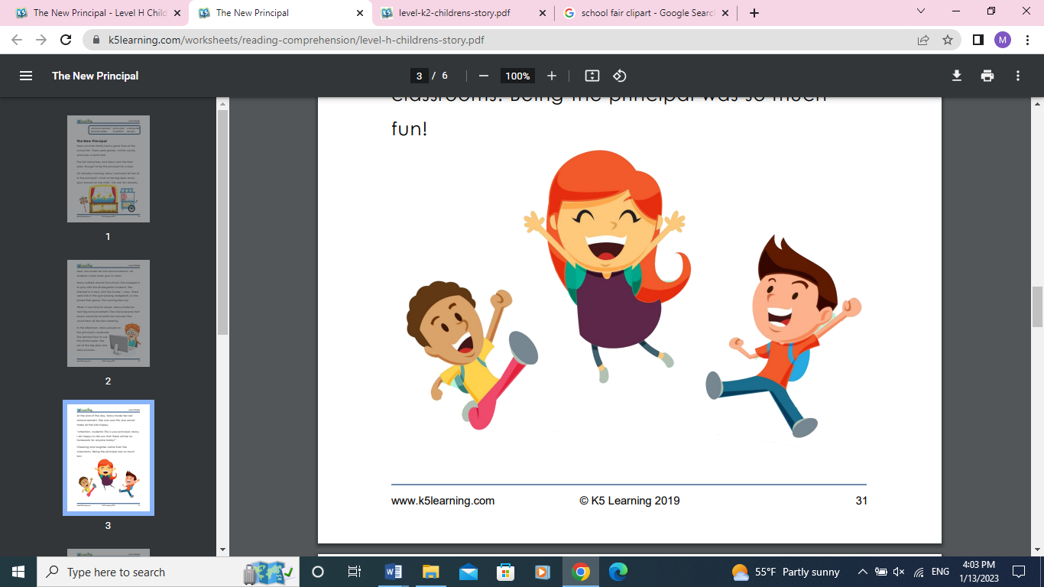

Teacher: Mirna Nawaf Al-Sahawneh.