

extra Comprehension text  **Grade 5**

Name ………………… Date: / /2023

A Visit to the Water Park

There is a new water park in town. We go there on the first day of summer. It has pools and water slides. There are sprinklers too. The slides are scary at first. After the first ride, we love the water slides. The sprinklers are cool on hot days. One of the pools makes its own waves. All the kids try to surf the waves. It is really fun. The water park can be very crowded. There are many kids and adults, but they do not allow pets. We really like the ice cream at the snack bar. They also sell pop and donuts. We all love the new water park.

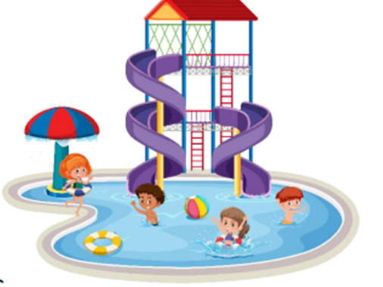

Teacher: Mirna Nawaf Al-Sahawneh.