

Practice Paper Unit ( 5 )

Three Poets

Grade (3)

Name: Date: / /2022

|  |
| --- |
| **Objectives:**  1. To identify the meaning of the new words.  2. To identify the synonym of the new words.  3. To use the new words in meaningful sentences. |

|  |  |  |
| --- | --- | --- |
| **Nouns** | **Meaning** | **Synonym** |
| **Ladybug** | A small red or orange insect with black spots.  **Example:**  There is a **ladybug** standing on the flower. |  |
| **Cricket** | A small brown insect, that jumps and makes a loud noise.  **Example**:  The **cricket** can’t be seen at night. |  |
| **Grasshopper** | An insect that can jump high in the air and makes a sound.  **Example**:  The **grasshopper** can be green and brown. |  |
| **Beetle** | An insect with hard wings and a shiny body.  **Example**:  I picked up the **beetle** carefully between finger and thumb. |  |
| **Bee** | A black and yellow insect that flies and makes honey.  **Example**:  There is a **bee** buzzed somewhere. |  |
| **Butterfly** | An insect with big wings that usually has bright colors.  **Example:**  I like to draw **butterflies.** |  |
| **Thicket** | A group of bushes or small trees.  **Example:**  Sara goes to the **thicket** that is near her garden. | A group of small trees. |
| **Kangaroo** | An animal from Australia that jumps on its strong back feet.  **Example:**  Australian **kangaroo** can hop very high. |  |
| **Raisin** | **dried fruit.**  **Example:**  I have some **raisins** in the jar. | dried fruit. |
| **Shooting star** | A long thin line of light in the night sky.  **Example:**  I waited the **shooting star** to tell my wish. |  |
| **Insects** | A very small animal that has six legs.  **Example:**  There are many amazing kinds of **insects** in the garden. |  |

|  |  |  |
| --- | --- | --- |
| **Adjective** | **Meaning** | **Synonym** |
| **Leaping** | **Jumping up high.**  Example:  The fish were **leaping** out of the water. | Jumping up high. |

|  |  |  |
| --- | --- | --- |
| **Verb** | **Meaning** | **Synonym** |
| **Escape** | **Get away.**  **Example:**  The thief **escaped** from the police. | Got away. |

**Q1) Put these sentences into the correct order.**

1. a poem / boy / The / wrote.

The boy wrote a poem.

2. ladybug/ red/ is / A/ black/ with/ spots.

A ladybug is red with black spots.

3. you / the summer / In/ see/ a lot/ can / insects/ of.

In the summer you can see a lot of insects.

**Q2) Match each word with its synonym.**

1. Raisin a. get away
2. Thicket b. Jumping up high
3. Escape c. a group of small trees.
4. Leaping d. dried fruit

|  |
| --- |
| 1.d 2. c 3. a 4. b |

**Q3) Write the correct word under each picture.**

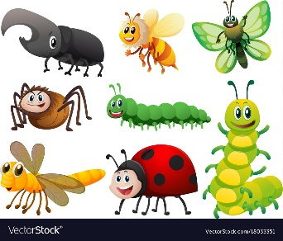  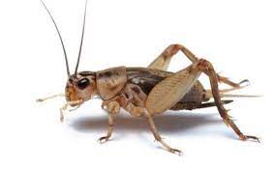

1 Insects 2. Shooting star 3. Cricket

 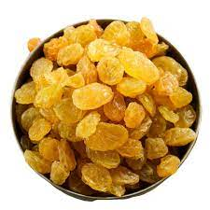 

4.Butterfly 5. Raisin 6. Leaping

**Q4) Complete the sentences using the words in the box.**

|  |
| --- |
| thicket, grasshopper, kangaroo, bee, escaped |

1. They **escaped** the fire by jumping out of the window of their second-floor apartment.

2.A **grasshopper** eats leaves. It is not good for plants.

3.Be careful! The **bee** is going to sting you.

4.The **kangaroo** is a big animal that has a big ears, long legs and short hands.

5.The **thicket** has many bushes and trees.

Teacher: Raneem Haddad.

Coordinator’s Signature:________________