

Worksheet Unit Five

Simple Past

Grade (3)

Name: Date: / /2022

|  |
| --- |
| **Objectives:**  1. To identify how to form the past tense in sentence, negative and question.  2. To practice using the simple past to talk about the actions that happened and finished in the past. |

•A verb in the past tense tells about an action that already happened.

**• The key words for simple past tense :**

Yesterday, last (week, night, month, year) -in 2003,at 6 o’clock yesterday …

* **Spelling rules of regular verbs:**

|  |  |  |  |
| --- | --- | --- | --- |
| -e + -ed | Consonant+ vowel + consonant  double consonant + -ed | Consonant + y  -y + -ied | Vowel + y  + -ed |
| lik**e** -like**d** | Pref**er** – prefe**rred** | Car**ry** - carr**ied** | Pl**ay** - pla**yed** |
| Hat**e** –Hate**d** | St**op** – sto**pped** | Stu**dy**-stud**ied** | Enj**oy** - enjo**yed** |

*There is no spelling rule for irregular verbs.

The form of the simple past :

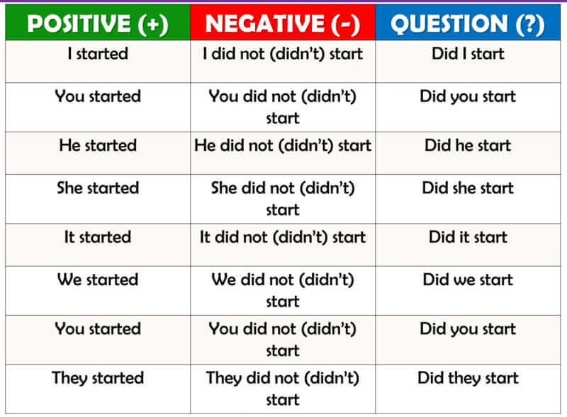

Irregular verbs:

|  |  |  |  |
| --- | --- | --- | --- |
| Base verb | Past verb | Base verb | Past verb |
| eat | ate | Buy | bought |
| drink | drank | Wake | Woke |
| swim | swam | Take | Took |
| run | ran | write | Wrote |
| sing | sang | Read | Read |
| go | went | See | Saw |
| sleep | slept | Come | Came |

**Example:**

I **woke** up at 6 o’clock yesterday.

I **drank** a glass of milk an hour ago.

**Q1) Write the past simple of the following verbs.**

1. Cry: cried 7. Eat: ate
2. Stay :stayed 8. Go: went
3. Travel: travelled 9.Sleep: slept
4. Live: lived 10.Write: wrote
5. Watch : watched
6. Close : closed

**Q2) Write the past tense form of each action verb in brackets.**

1. The baby **cried** **(cry)** too much last night.
2. The father **washed** **(wash)** the car .
3. Seagulls **carried** **(carry)** away bits of food.
4. Jack and Sam **went** **(go)** to the zoo. It was fun.
5. Stray twigs **skipped** **(skip)** across the water.
6. Talia **bought** **(buy)** some sweets.
7. The boy **swam** **(swim)** happily in the river.
8. We **travelled** (**travel)** to China last year.

**Q3) Order these words to make meaningful sentences.**

1. I / my /ate /meal/ favorite.

**I ate my favorite meal .**

1. watched / in the/ He/ living room / TV.

**He watched TV in the living room .**

**Q4) Change these sentences into question and negative sentence .**

**Ex**: They visited their friend last week.

**Negative** : They didn’t visit their friend last week .

**Question** :Did they visit their friend last week ?

1. She went to the mall last Friday .

Negative : She didn’t go to the mall last Friday.

Question: Did she go to the mall last Friday?

1. We played football yesterday .

Negative: We didn’t play football yesterday.

Question: Did you play football yesterday?

Teacher : Raneem Haddad Coordinator’s Signature : ------------------