

Practice Paper Unit ( 6 )

From the world to your table

Grade (4)

Name: Date: / /2022

|  |
| --- |
| **Objectives:**  1. To identify the meaning of the new words.  2. To identify the synonym of the new words.  3. To use the new words in meaningful sentences. |

|  |  |  |
| --- | --- | --- |
| **Verbs** | **Meaning** | **Synonym** |
| **Export** | To **send** to another country to sell.  **Example**:  Japan **exports** cars to the United States. | To send / transport |
| **Decrease** | To **become less** or smaller.  **Example**:  The price of gas **decreased**. | To become less/ drop |
| **Improve** | To **become better**.  **Example**:  Salt and pepper **improved** the sauce. | To become better. |

|  |  |  |
| --- | --- | --- |
| **Process** | **Change.**  **Example**:  Companies **process** and package most of the food before it gets to the supermarket. | Change |
| **Package** | To **wrap** something or put something into a box before it is sold or sent somewhere.  **Example**:  My mom and I **packaged** a special present to my grandmother. | Wrap |

|  |  |  |
| --- | --- | --- |
| **Nouns** | **Meaning** | **Synonym** |
| **Century** | **One hundred years.**  **Example**:  The Roman Empire existed for several **centuries.** | 100 years |
| **Agriculture** | **Farming**  **Example**:  Agriculture has changed a great deal in the last 100 years | Farming |
| **Grocery** | The **food** and other things sold in such a store.  **Example**:  We need to pick up some **groceries** on the way to home. | Food  d |
| **Energy** | The **power** or ability to make something work or be active.  **Example**:  Plants use the **energy** of the sun to grow. | Power |

|  |  |  |
| --- | --- | --- |
| **Adjective** | **Meaning** | **Synonym** |
| **Possible** | **Likely.**  **Example:**  If he didn't answer, it's **possible** that he didn't hear you. | likely |
| **Local** | **Regional.**  **Example**:  We buy some food from our **local** farmer’s market. | Regional |
| **Chemicals** | **Solid or liquid substances** that scientists study and use**.**  **Example**:  The science teacher showed us two kinds of **chemical** reactions today. |  |
| **Delicious** | **Tasty**  **Example:**  The apple pie is **delicious*.*** | Tasty |
| **Convenient** | **Easily used.**  **Example**:   I find the new system that is much more **convenient**. | Easily used |
| **Organic** | **Natural.**  **Example**:  Buy **organic** food, which doesn’t have chemicals on it. | Natural |

**Q1) Order these words to make meaningful sentences.**

1. Try/ your/ more /of /food /own/to grow.

Try more to grow of your own food.

2. Companies / on /food /help/chemicals / to /last /it /longer/put.

Companies put chemicals on food to help it last longer.

**Q2) Match each word with its synonym.**

1. Local a. power
2. Export b. become less
3. Delicious c. regional
4. Decrease d. transport
5. Energy e. tasty

|  |
| --- |
| 1.c 2. d 3. e 4. b 5. a |

**Q3) Write the correct word under each picture.**

1. 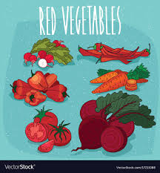 2. 3.

Transport/ Export Tasty/Delicious Organic/ Natural

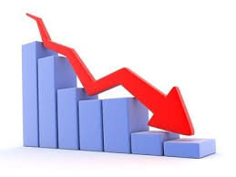

1. 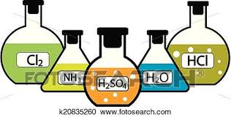 5.  6.

Chemical Process Improve

**Q3) Complete the sentences using the words in the box.**

|  |
| --- |
| decrease, improve, organic, delicious, energy, export |

1. People are willing to pay more for **organic** food.
2. This is not good enough. I want to **improve** my hand writing.
3. People should **decrease** the amount of fat they eat.
4. A lot of our land is used to grow crops for **export**.
5. My mum made a **delicious** cinnamon bun.
6. The kids are always so full of **energy**.

Teacher : Raneem Haddad.

Coordinator’s Signature : _________________.