

**Grammar Worksheet**

Simple Present

Grade ( 4 )

Name: Date: / /2022

|  |
| --- |
| **Objectives:**  1.To learn how to form and use simple present tense.  2.To practice using the present simple. |

*The simple present is used:

To express habits, daily routine, and facts.

*The form of simple present.

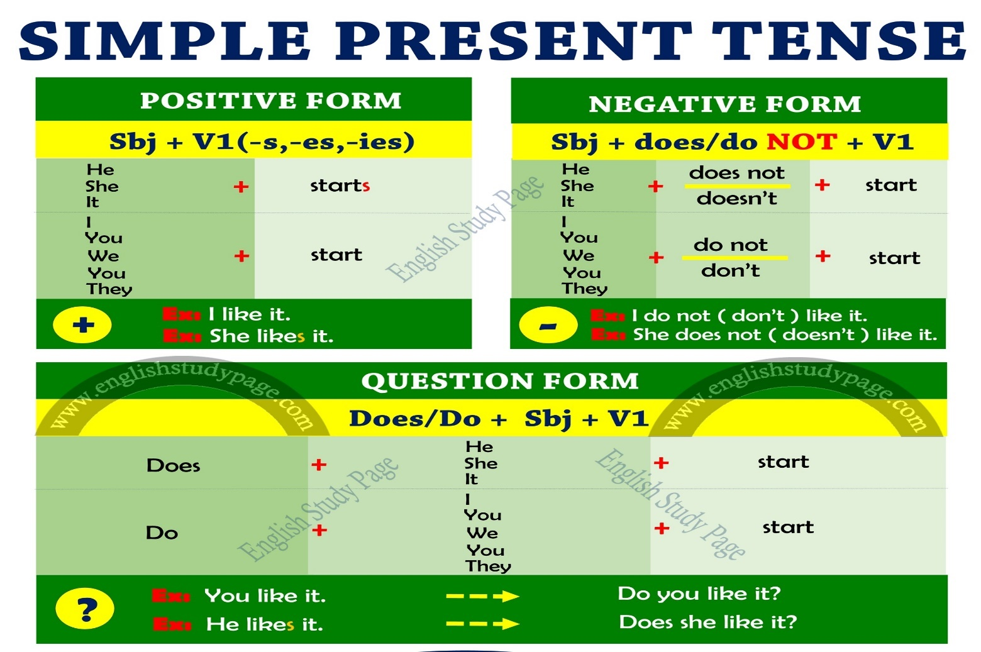

**Time Expression:**

**Every (day,night,week,month,year…) , always , usually, often, sometimes, never.**

**Spelling Rules :**

We add “**s,es,ies**” to the verbs after (**He , She, It**) and Singular nouns.

|  |  |
| --- | --- |
| **Spelling Rules** | **Examples** |
| With most verbs, add **s** | Write - write**s**  Swim -swim**s**  Run- run**s**  Walk- walk**s** |
| verbs that end in ( sh/ch/x/o/z/s) , add **es** | Wa**sh** – wash**es**  Wat**ch**- watch**es**  Pas**s** – pass**es**  G**o** – go**es**  Fi**x**- fix**es** |
| Verbs that end in **consonant + y** change **y** to **i** and add **es** | T**ry** – tr**ies**  C**ry**- cr**ies**  Car**ry** – carr**ies** |
| Verbs that end in vowel + y just add **s** | Pl**ay**- play**s**  S**ay**- say**s** |

Examples :

I **visit** my grandparents every Friday.

She **visits** her grandparents every Friday .

They always **catch** the ball.

He always **catches** the ball.

We always **try** to win .

She **carries** her little brother.

**Q1) For each verb below, write the present simple form that agrees with the subject given.**

* Carry Lana carries .
* watch Mike watches .
* wash I wash .
* pass You pass .
* guess Flora guesses .
* push Osama pushes .
* match I match .

**Q2) Order the words to make sentences.**

1. doesn’t/to school/go / every morning/ He.

He doesn’t go to school everymorning.

1. always /drink /on / water/ I /the morning.

I always drink water on the morning.

1. watches/film /My mom / favorite / every day/her.

My mom watcher her favorite film every day.

**Q3) Complete the sentences with the correct form of the verbs in brackets.**

1. I **take** (**take)** pictures with my family on my birthday.
2. Rand **passes** **(pass)** her exams.
3. Marla **doesn’t work** **(not/work)** in the hospital.
4. My father and I **don’t make** (**not/make**) breakfast every morning.
5. Mona **studies** (**study**) Math every day.
6. The bird **lays** (**lay)** eggs in its nest.
7. The train **arrives** (**arrive**) at 10:00 am.
8. **Do** Shady and Ramzi **buy** **(buy)** fruits every Saturday form the local store?
9. **Does** the parrot **fly** (**fly)** far away?
10. The teacher **teaches** (**teach**) us grammar.

**Q4) Circle the correct answer.**

1. Children usually ------- chocolate.
2. **eat b. eating c. eats**
3. She--------- to her piano lesson every Monday.
4. **went b. goes c. go**
5. --------- they------- in the same team?
6. **Does/play b. Do/plays c. Do/play**
7. Talia---------coffee in the morning.

**a.don’t drink b. doesn’t drink c.does’nt drinks**

**5)** Jack ----------Science with his friend.

**a. study b. studies c. studys**

**Q5) Change these sentences into question and negative sentence.**

**Ex**: My brother eats bananas.

**Negative**: He doesn’t eat bananas.

**Question**: Does he eat bananas?

1. The sun shines brightly on the morning.

Negative: The sun doesn’t shine brightly on the morning.

Question: Does the sun shine brightly on the morning?

1. They often solve the puzzle.

Negative: They don’t solve the puzzle.

Question: Do they solve the puzzle?

1. I tidy up my bed room every morning.

Negative: I don’t tidy up my bed room every morning.

Question: Do you tidy up your room every morning?

**Q6) Write 2 sentences about something you do every day. Use simple present tense.**

**1.I always brush my teeth.**

**2. I drink milk every morning.**

Teacher : Raneem Haddad

Coordinator’s Signature : _________________.