

Grammar worksheet

Polite offers

Grade ( 4 )

Name: Date: / /2022

|  |
| --- |
| Objectives:  How to ask in a polite way.  To practice offering in a polite way. |

* We use _ **would you like to .**

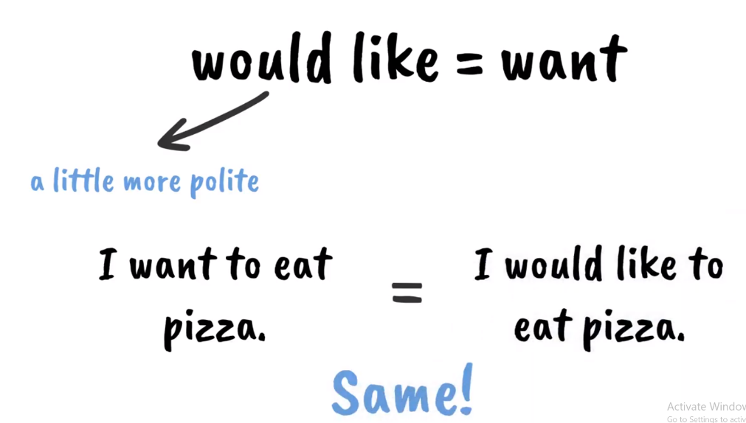

1.

2.**To offer things:**

Would you like a cup of coffee?

Would you like a piece of pizza?

3.**To offer actions:**

Would you like to watch a film with us?

Would you like to drink a cup of tea?

* You can use a **verb or a noun** after would

**Would you like + noun**

1. Would you like **a cup of tea?**
2. Would you like **some chocolate?**
3. Would you like **an orange juice?**

**Would you like + verb (infinitive)**

1. Would you like **to eat** pizza?
2. Would you like **to go** to the park today?
3. Would you like **to drink** orange juice?

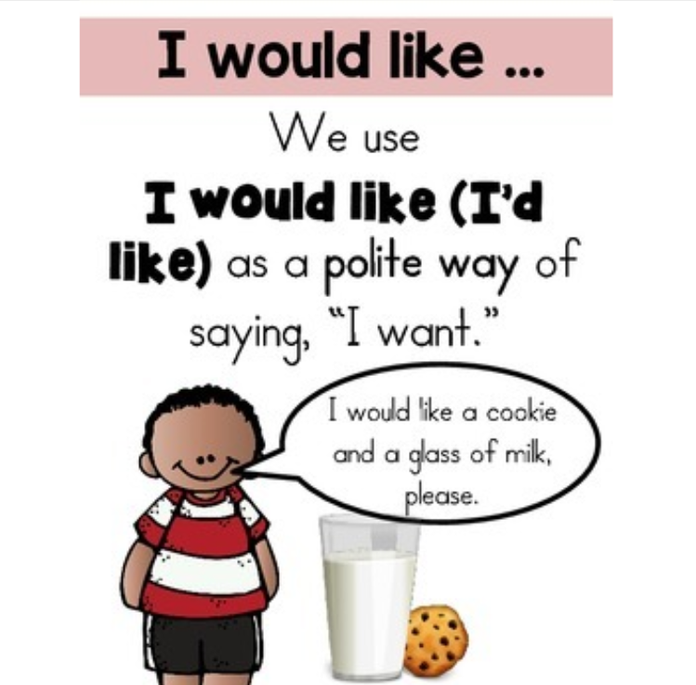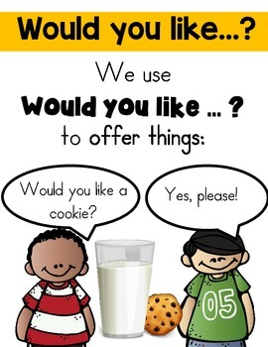

**Exercises**:

**Choose the correct answer.**

1. I ------------. like to help you.
2. **would**  b. **wood**  c. **woud**
3. I would like ------------- cup cake.
4. **to** b. **a** c. **an**
5. I would like --------------- thank you.
6. **to** b. **a** c. **an**
7. ---------------- like a cup of coffee?
8. **Would** b.**do you want** c. **Would you**
9. Would you like --------- order something**?**

a**.a** b**.to** c**. an**

**Q2) Change the sentences into questions. Use the polite offer ( Would you like).**

1. I want to drink a cup of tea.

Would you like to drink a cup of tea?

1. Sara wants to eat a sandwich.

Would you like to eat a sandwich?

1. We want a cake for breakfast.

Would you like a cake for breakfast?

1. We want to order some cookies.

Would you like to order some cookies?

**Q3) Complete the polite offer questions with (to, a, an or some).**

1. Would you like **to** read my report about chemicals?
2. Would you like **some** cookies with your milk?
3. Would you like **to** help me in my homework?
4. Would you like **a** can of Pepsi?
5. Would you like **to** buy some apples from the grocery store?
6. Would you like----------- orange?

Teacher: Raneem Haddad.

Coordinator’s Signature:________________