

**The Primary Stage of Grades (4-5)**

**School Year 2022 - 2023**

**Name:** ____________ **Subject: Final Revision Worksheet**

**Date:**  / / 2022  **Class: Grade 5National A+B**

**­­­__________________________________________________________**

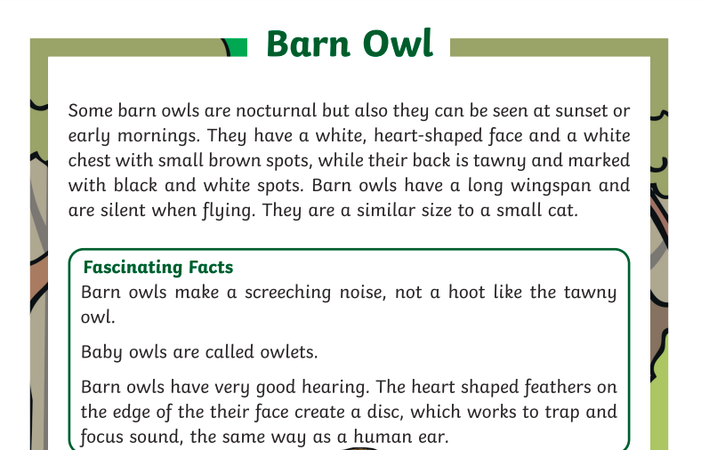Read the following passage then answer questions.



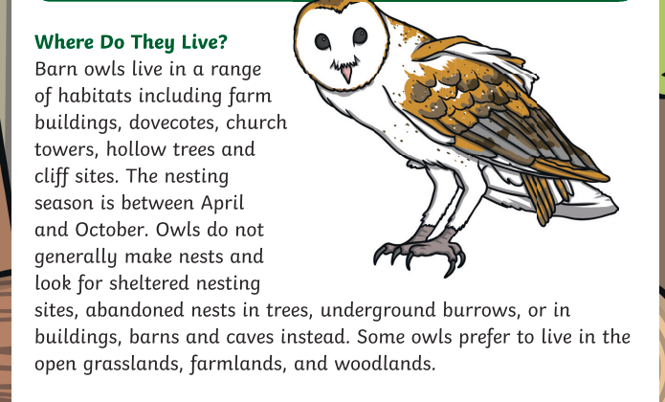

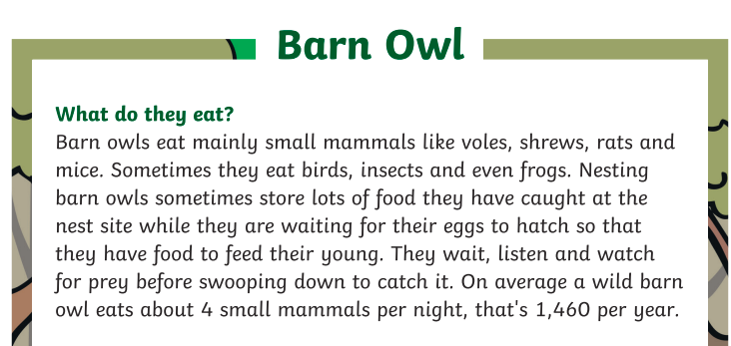

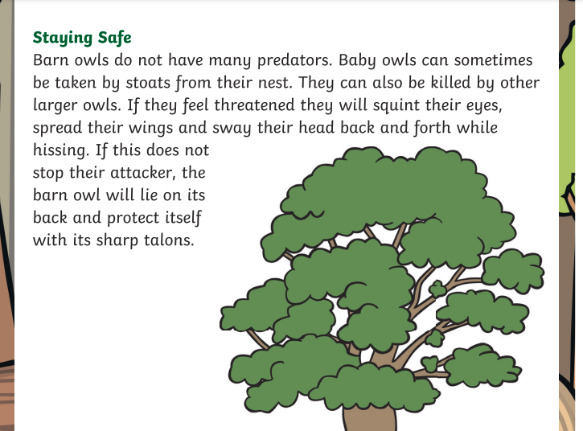

1. **Which words describe what a barn owl looks like?**

__________________________________________________________________________________________________________________________

1. **Do barn owls make their own nests?**

**_____________________________________________________________**

1. **Where do barn owls live?**

**__________________________________________________________________________________________________________________________**

1. **What do they do if they feel threatened?**

**__________________________________________________________________________________________________________________________**

1. **What do barn owls eat?**

**__________________________________________________________________________________________________________________________**

1. **How do barn owls catch their prey?**

**__________________________________________________________________________________________________________________________**

1. **How many animals does a barn owl eat each night?**

**__________________________________________________________________________________________________________________________**

1. **How do barn owls hear?**

**__________________________________________________________________________________________________________________________**

1. **What is the purpose of the introduction?**

**__________________________________________________________________________________________________________________________**

1. **The underlined pronoun “They” refer to _________________:**

**“**Some barn owls are nocturnal but also **they** can be seen at sunset or early mornings. They have a white, heart-shaped face and a white chest with small brown spots,”

**Vocabulary:**

**1. Fill in the blanks using the words inside the box. There is an extra word.**

|  |
| --- |
| endangered - munched - molars – jaws – incisors -sliced - cavity - |

1. Amy felt a pain when she ____________________ some popcorn.
2. The dentist found a small ___________________ in Amy’s sore tooth.
3. The boy opens his ____________________ wide for the dentist.
4. The chef _______________________the lemon.
5. The pain was in one of Amy’s_________________________.
6. The dentist checked Amy’s canines, ___________________, and molars.

**2. Choose A, B, C or D. Write the correct letter in the box**.

What does the word **“cavity”** mean?

1. A hole in a tooth.
2. A formal public or religious event.
3. A small wooden house.
4. Helpful

**3. Which word means the following “to take and keep hold of someone or something firmly.”**

a. crush

b. dental

c. detective

d. grip

**Grammar**

**1. Circle the correct answers.**

1 I ________________write my name when I was four.

a couldn’t b can’t c won’t be able to

2 Anna ______________speak English when she was five.

a can b could c will be able to

3 He has practice tomorrow. He _________________go to the movies.

a can’t b couldn’t c won’t be able to

4 I get my library card tomorrow. I __________________check out books.

a can b could c will be able to

**2. Use (could, can, or will be able to) to complete the sentences.**

1. I __________________run faster than my sister last year.

2. She___________________ walk to the store alone next year.

3. They______________________ catch a baseball when they were eight.

4. My little brother ______________________tie his shoes when he gets older.

**3. Complete the following text using the words from the box below.**

|  |
| --- |
| Could – will be able to – can – couldn’t – can’t – won’t be able to |

Toby was very sick yesterday. His stomach hurt and he ______________ eat any food. He ________________ drink a little water, but he wasn’t very thirsty. He ________________ play soccer in the park with his friends, so he stayed in bed and read his book. He is feeling a little better today. He ________________drink a little soup, but he ________________eat very much. He ________________go to school, because he still feels sick and tired.

Toby has taken some medicine now, so he hopes he __________________ go to school tomorrow. He wants to eat more food tomorrow, too. Toby’s mother says he __________________have sweet foods tomorrow because they are not good for his stomach, but Toby thinks he ____________________ eat a small piece of cake!

**3. Complete the following sentences using the correct tense of the verbs in brackets. (simple present tense, simple past tense or present continuous)**

1. My dad ________________ (take) me to school by car every day.

2. Yesterday, Lisa __________________ (open) her presents.

3. Peter and Sally __________________ (listen) to rock music now.

4. __________you ___________ (clean) your room last night?

5. Sally __________________ (visit) her hairdresser’s every month.

6. I ___________________ (meet) a friend at the shopping centre this afternoon.

7. Mary __________________ (play) in music concerts when she was a child.

8. ______________ he ___________ (finish) his project at 11 o’clock last night?

9. _____________ you _________________ (come) to Ann’s part tonight?

10. The plane __________________ (leave) at 9:30 am.

11. James ___________________ (not/ win) the award in 2020.

12. She __________________ (listen) to music every morning.

13. Be quit, please! My children __________________ (try) to sleep.

14. They __________________ (not/ go) to school on weekends.

15. He __________________ (not/ marry) her she __________________ (break) up with him last year.

**4. Find and correct the mistakes in the following sentences.**

1. Jack goed to school yesterday. _________________________

2. Mark could drive a car in a month. _____________________

3. Jude listening to music with her friends at the moment. _______________

4. The police don’t catch the thief last week. ________________

**Spelling**

**1. Choose the correct answer.**

1.The moon was just clearly **(visible/ invisible)** between the clouds.

2. The building was left **(incomplete/ complete).** They need one or two months more.

3. The test results are **(incorrect/accurate)** in 99% of cases.

4. The story is believable. It is **(credible/ incredible).**

**2. Write the synonym for the following words.**

a. error -----------------------------

b. tale _________________

c. bright _______________