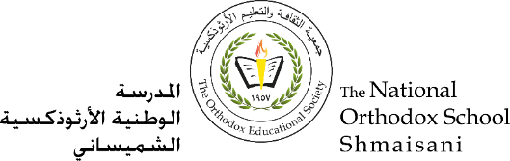

**The Primary Stage of Grades (4-5)**

**School Year 2022 - 2023**

**In The name of The Father, The Son and The Holy Spirit. Amen**

**Worksheet N.(4)**

**Name** : ___________ **Subject** : **The Holy Bible**

**Date : / / Class : Grade five (All Sections)**

**_____________________________________________________________**

**The Holy Bible**

|  |
| --- |
| **Golden verse:**  **“Blessed are those who hear the word of God and keep it” (Luke 11:28)** |

1- What is The Holy Bible?

TheHoly Bible is God’s words which were sent to us through His prophets and apostle and is written by The Holy Spirit inspiration.

2-What are the parts of the Holy Bible?

The Old Testament.

The New Testament.

3-What is the meaning of Gospel?

The Good News.



4-What are The New Testament sections?

The four Gospels.

The acts of the Apostles.

The Letters.

The Revelation

5-How many texts in The Old Testament?

There are 39 texts.

6-How many texts in The New Testament?

There are 27 texts.

7- Why is the Bible important?

Because it is the first source of faith.

8- What does the Bible teach us?

It teaches us how to live the true faith in our lives.

9- Who interprets the Bible and why?

The Holy Fathers, because the grace of the Holy Spirit works with them.

10- Choose (True) or (false)

a- Placing the Holy Gospel on the holy table in the church symbolizes the presence of Christ (True)

b-The Holy Bible is different from the New Testament (False)

c-Moses the Prophet is the main character in the Bible (False)

d-I can interpret the Bible verses based on my knowledge and understanding of the verses . (False)

e-The Bible is the only reference for my faith in Christ. (False)

f-The Holy Church interprets the Holy Bible based on the interpretations of the Holy Fathers, inspired by the Holy Spirit. (True)

g-To memorize the Bible means to live by its words in my life. (True)

God bless you