 **The National Orthodox School/ Shmaisani**

**Name: ……………………….. … Subject: Science/ Physics**

**Worksheet 3 : Sankey diagram**

**Date………….………… Grade 6 CS ( B C D E F )**

**Sound energy 50 J**

## The picture shows a Sankey diagram for an electric device.

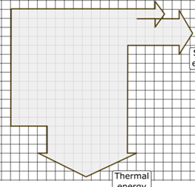

**Electrical energy 400J**

**Light energy _____ J**

Answer the following questions according to this picture.

Question 1 :

1. What is/are the useful and the wasted energy?

**Thermal energy 250 J**

Useful: ___________________________.

Wasted: _________________________.

1. The type of input energy for this device is: __________________.
2. Calculate the amount of light energy in this device: _______________________.
3. The total amount of output energy in this device is ___________.

c) The amount of input energy in this device is: ________________.

Question 2:

Is the device represented by the Sankey diagram shown in the picture efficient or inefficient?

………………………………………………………………

Why?

………………………………………………………………………………………………………

Question 3:

This Sankey diagram represents the energy transfer taking place in an electrical device. Which electrical device can it be?

………………………………………………………………….