**Write a descriptive paragraph describing the following old photo.**

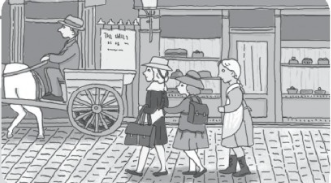**Make sure you:**

1. **Include an interesting title.**
2. **Introduce your paragraph with a topic sentence.**
3. **Describe what you saw, heard, smelled, tasted, and touched.**
4. **Write what you learned from the photograph.**

**A Photo from the Past**

Recently, I saw a photograph that someone took in Germany in 1890. It taught me many things about the past.

In this picture, I can see three girls walking to school. They are wearing cotton skirts. Next, there is a horse and a wagon. I can imagine the sound of the horse’s hooves. There is also a bakery. I can almost smell the fresh bread and taste it.

This photo taught me that people in the past used horses for transportation and children needed to go to school, just as we do today.