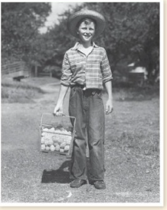**Write a descriptive paragraph describing the following old photo.**

**Make sure you:**

1. **Include an interesting title.**
2. **Introduce your paragraph with a topic sentence.**
3. **Describe what you saw, heard, smelled, tasted, and touched.**
4. **Write what you learned from the photograph.**

**A Picture from the Past**

Yesterday I found a picture of my great- grand father when he was ten years old. Because of it, I learned about the past.

In the picture, I can see my grandfather, a farm, a basket of eggs and a chicken coop near the wooden bridge. In my mind, I can smell the fresh air. I can hear the sound of the chickens and I can almost taste their delicious eggs.

This photograph taught me that people lived simply and looked very happy and healthy in the past.