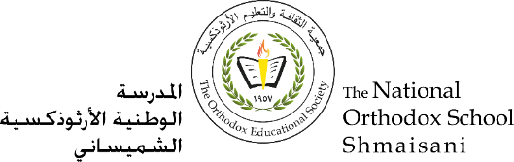

**The Primary Stage of Grades (4-5)**

**School Year 2022 - 2023**

**The name of The Father, The Son and The Holy Spirit. Amen**

**Name**: ___________ **Subject**:

**Date: / / Class: Grade four**

**Jesus teaches in the temple**

|  |
| --- |
| **Golden verse: “God in the highest, and on the earth peace among men with whom he is well pleased.”(Luke 2:13** |

1-Circle the correct answer?

1-Where do the people go to pray on Feast?

A-Bethlehem **b-Jerusalem**.

2-Jesus went with his parents on Feast when he was old:

**a-12 years old** b-2 years

3- Jesus’s parents found him after:

a-7 days **b- 3 days**

Q2- What Jesus was doing when his partents found him?

A2- they found him in the temple, sitting among the teachers, listening to them and asking them



Q3-Who said :

1-Son ,why have you treated us so ?

**Mother of God**

2-Your father and I have been searching for you in great distress.

**Mother of God**

3-Did you not know that I must be in my Father’s house ?

**Jesus**

_Q4- How was Jesus increased with God and man ?

A4- Jesus increased in **wisdom** and in **stature**and in **favor** with God and man.

Q5-How can you grow spiritually on the example of the Lord Jesus Christ ?

A5- I can through:

1-Reading The Holly Bible

2-Attending The Divine Liturgy

3-Individual prayer.

4-Daily prayer with family.

Q6-Where was Jesus born?

- Jesus was born in **Bethlehem**

Q7-The **three magi** came from the Orient to see Jesus Christ and gave him gifts which were:

**Gold (means**) **Frankincense (means)** **Myrrh (means)**

(**Jesus the greatest King) (Jesus the greatest priest) (Jesus was crucified for** us**)**

Q8 - The parents of Virgin Mary are **Joachim** and **Anne**.

-God sent the **angel Gabriel** to Virgin Mary in **Nazareth** to for tell her the Birth of Jesus Christ

-The angel said to Virgin Mary :Behold you will conceive in your womb and bring forth a son and will call his name **Jesus.**

Mary said to angel Gabriel :”**Behold, the handmaid of the Lord;** be it to meaccording to your word.”

The parents of Virgin Mary are **Joachim** and **Anne**.

God bless you