
Fast is fine, but accuracy is every thing

Worksheet (15)
Grade 1(A+B)
Name: ------------ Date: / 11/2022
_________________________________________________ Objective: To practise using verb to be in the present tense.
pronouns | Long form | Short form | Example
I | am | ’m | -I am a boy.  -I’m a boy.
He | is | ’s | -He is six years old.  - He’s six years old.
She | is | ’s | -She is Emma.  - She’s Emma.
You | are | You’re | -You are my friend.
They | are | They’re | -They are my sisters.
We | are | We’re | -We are in grade two.
Negative
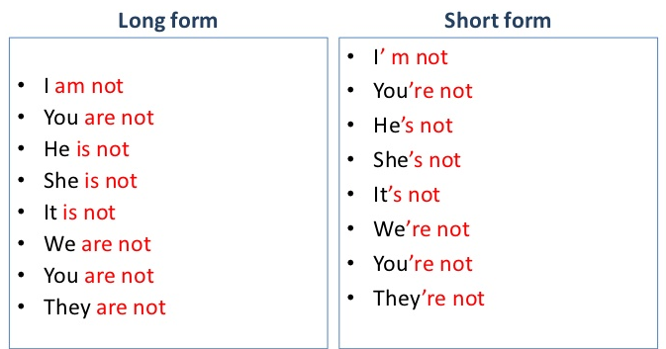

- Fill in the blanks with (is, am or are).
1-Salma _____ my best friend.
2-Sami______ my brother.
3-Zeina and Sanad ______ twins.
4- My cat____ black.
5-I ______ a doctor.
6- She ______ my grandmother.
7- Aoun and I _______ good students.

- Correct the mistakes in the sentences below.
1-Michael and I am cousins. ________________
2- Zaid and Hamdi is in grade nine. ___________
3- My uncle are a doctor. ________
4- They are lovely friend. ________
5- I have a black car. It is red._______

T.Taghreed Alnimri Coordinator’s Signature:


