
Meaning Worksheet(3)
Grade 2
Name: Date: /11 /2022
Objectives: To identify the meaning of new words.
To practise using the new words in sentences.
- Study the words below:
word | meaning
flow | 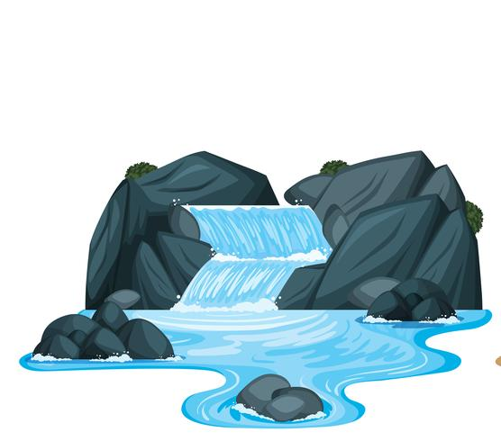
solid | 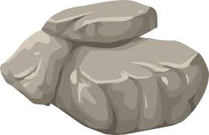
liquid | 
gas | 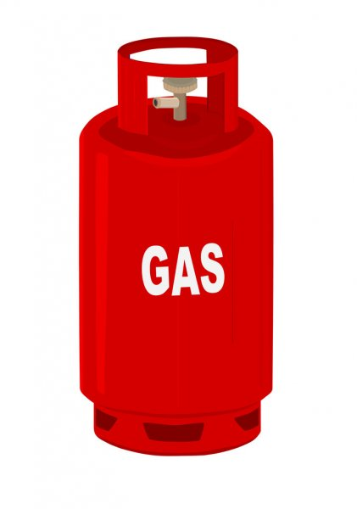
heat | 
steam | 
ice | 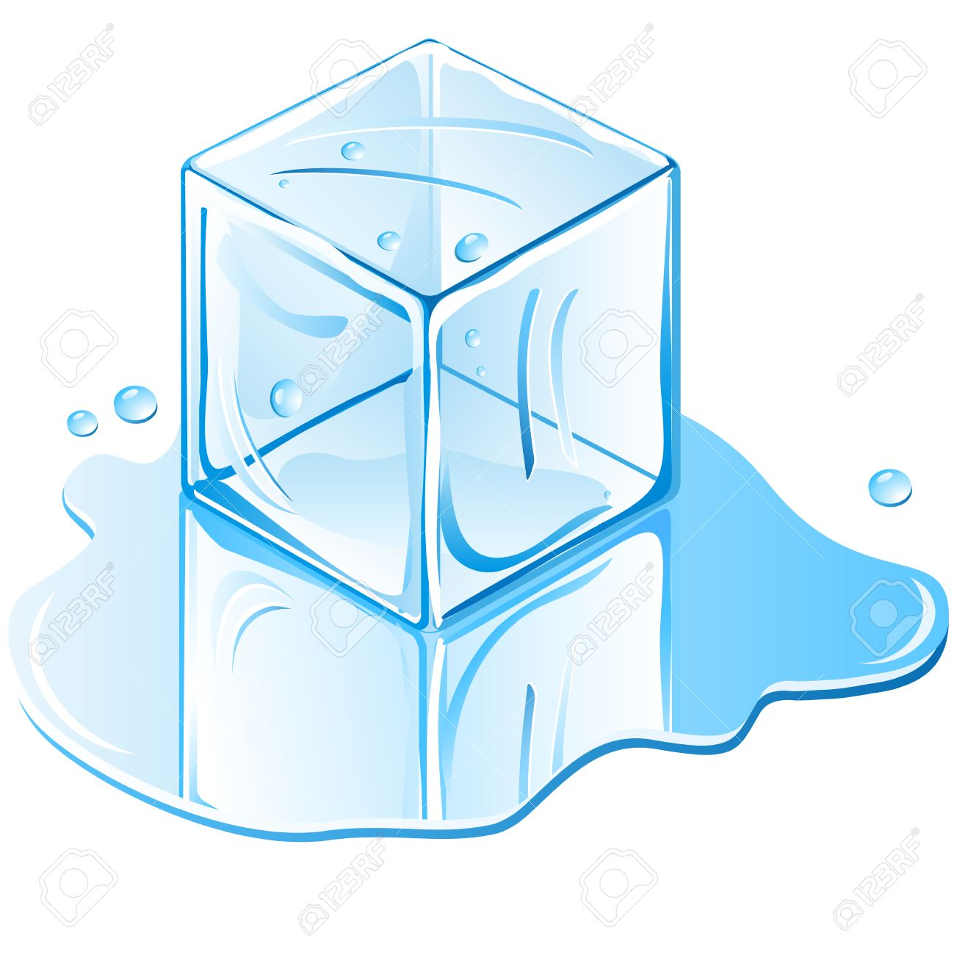
freeze | 
melt | 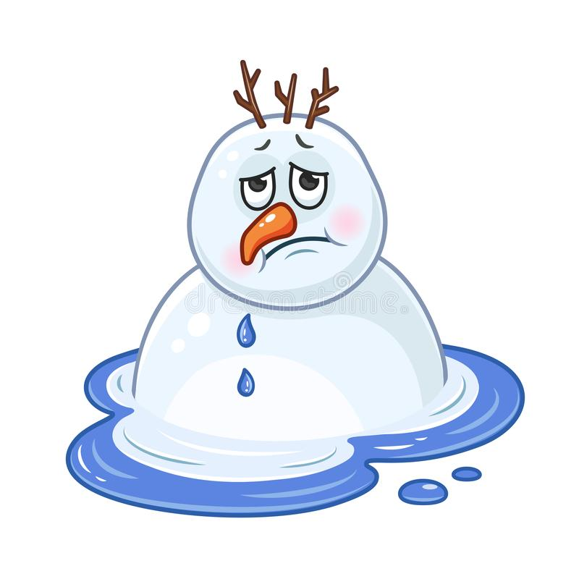
2) Circle the correct word:
steam - liquid - ice
heat - freeze - melt
gas - liquid - soli

3)Fill in the blanks with the correct word:
flows liquid steam freeze solid

- Milk is a ____________.
- When I want to make something very cold. I _______ it.
- Water changes into _________ when it is boiled.
- Liquid can___________.
- ________can be hard and soft.

T.Taghreed Alnimri

