

**The Primary Stage of Grades (4-5)**

**School Year 2022 - 2023**

**Name** : ___________ **Subject** : writing worksheet #5

**Date : / / Class : Grade 4 CP (All Sections)**

**_____________________________________________________________**

**Objective/ To write a non- chronological report about an animal or insect.**

**Read the non-chronological report about butterflies.**

**Model text:**

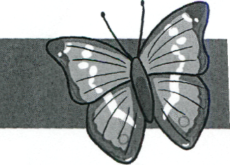

All about...

Butterflies

Butterflies are some of the most interesting insects in the world. There are over seventeen thousand different species worldwide.

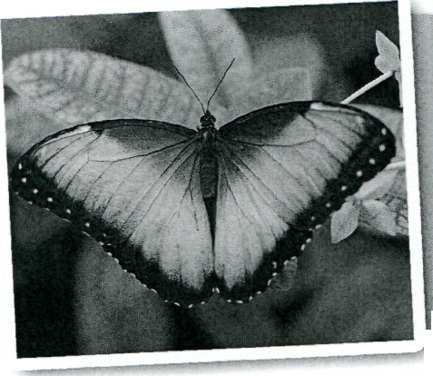

**Fascinating Facts**

A butterfly's life cycle is made up of four parts.

1. The female butterfly lays her egg on a leaf.

2. The egg hatches and a caterpillar comes out. It lives and eats on the leaf where it was born and will shed its skin many times.

3. When the caterpillar has grown much bigger, it creates a chrysalis.

4. Inside the chrysalis the caterpillar turns into a butterfly, the chrysalis breaks open and a butterfly comes out.

Butterflies can live for between 2 days and 11 months.

**Where Do They Live?**

Butterflies live in lots of different places depending on what season it is. They like to live in warm places and can be found in many countries around the world. Butterflies tend to live where they can find food. They are awake during the day looking for food and at night they may be found on the underside of a leaf or tucked away in a crevice in a rock.

**What Do They Eat?**

Butterflies get all of the food they need by drinking. They have a long, thin tube in their mouth called a pro­boscis, which they use like a straw to suck up their food. Adult butterflies eat all sorts of things, such as juices from oranges and watermelons. They also eat nectar from different types of flowers and water.

**Staying Safe**

Some types of butterflies have eye spots on their wings. If a predator comes near, they flutter their wings, showing their eye spots, which scares the predator away. Some butterflies taste horrible and bright colours usually warn other animals of this.

**https://youtu.be/_0F7wFPRBmY**

* **After reading the model text, write a non-chronological report about an animal or insect that you have information about.**

Use the planning box to make your plan.

Write your report here

**Humans’ Best Friend**

Dogs have been friends for humans for twelve thousand years. Dogs are mammals and warm blooded.

**Did you know?**

Dogs’ noses are one of a kind just like human fingerprints!

**What do dogs eat?**

Dogs are omnivores. They can eat meat and plants. You should never feed a dog chocolate as it makes them sick.

**What can dogs do?**

Dogs are really playful. They can run about nineteen miles per hour. Dogs can check out strong smells. They also can see very well in dark.

**Looking After Dogs**

Dogs like walking, so they need to go out for a walk every day. They need healthy food. Their fur needs to be brushed to stay clean.

Dogs are the first animals domesticated by humans. On average, they live for about 13 human years.

|  |  |
| --- | --- |
| ***My Writing Checklist*** | ***√*** |
| Did I punctuate the sentences correctly? |  |
| Did I include a title and subheadings? |  |
| Did I include factual information about dogs? |  |
| Did I use simple present tense? |  |
| Did I use third person point of view? |  |

|  |  |
| --- | --- |
| Purpose and audience | /3 |
| Text structure | /3 |
| Sentence structure | /3 |
| Vocabulary | /2 |
| Spelling | /2 |
| punctuation | /2 |
| Total | /15 |