

**Python 2**

**Name: …………………. Grade / Section: ….**

**Date: …………………. 1st Semester 2022/ 2023**

**Syntax of if … else**

|  |
| --- |
| **if test expression:**  **Code to run when test expression is TRUE**  **else:**  **Code to run when test expression is FALSE** |

The if...else statement evaluates test expression and will execute the body of if only when the test conditions is **True**.

If the condition is **False**, the body of else is executed.

**Examples:**

1. **Write a program that:**

a. Input and print your name.

b. Input the 1st and the 2nd Mark then calculate and print the average.   
 Average = (first + second) / 2

Then

c. If the Average is greater than or equal to 50 print (“Pass”)   
 else print (“Fail”)

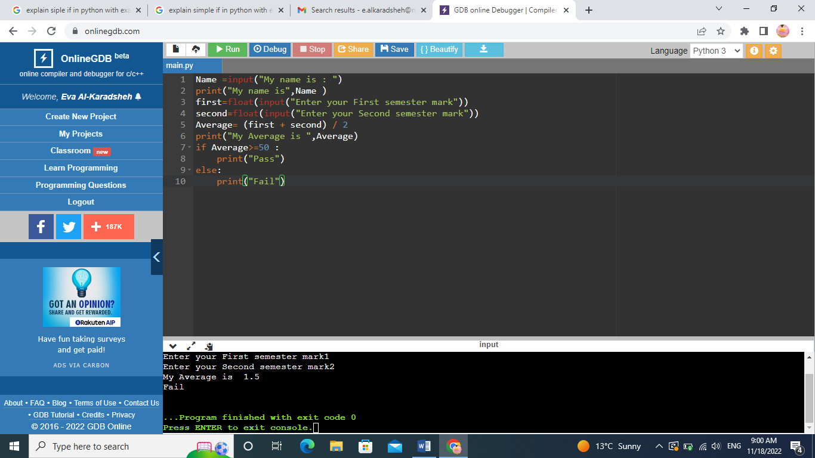

1. **Write a program to check if a number is positive or negative.**

(If a number is greater than zero, it is a positive number. If a number is less than zero, it is a negative number.)

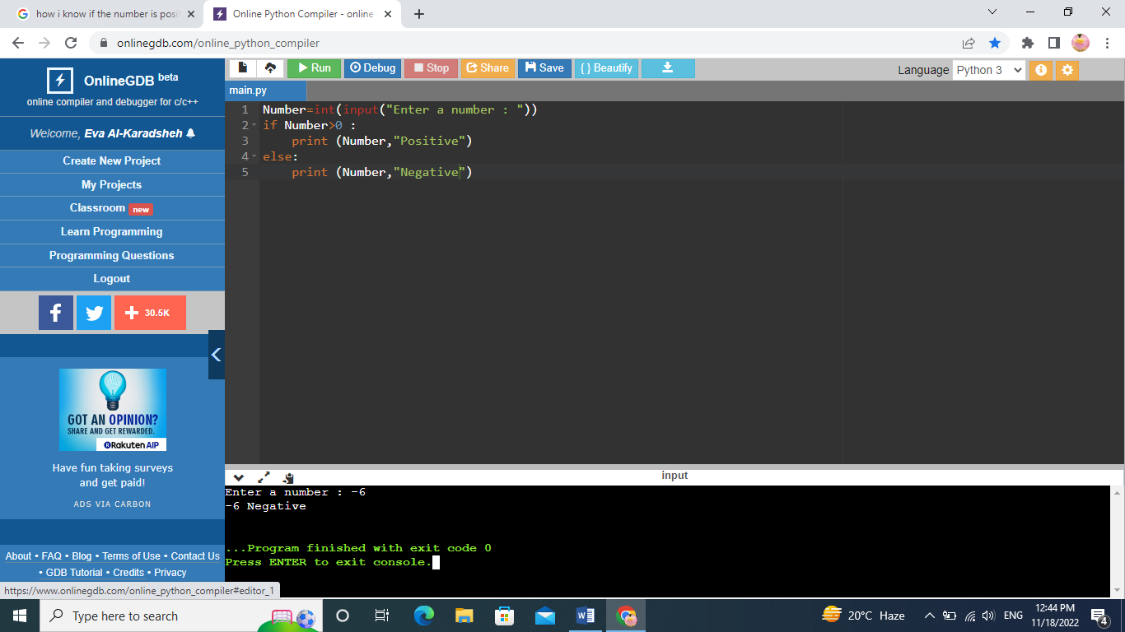

1. **Write a program that compare two numbers and print the largest**

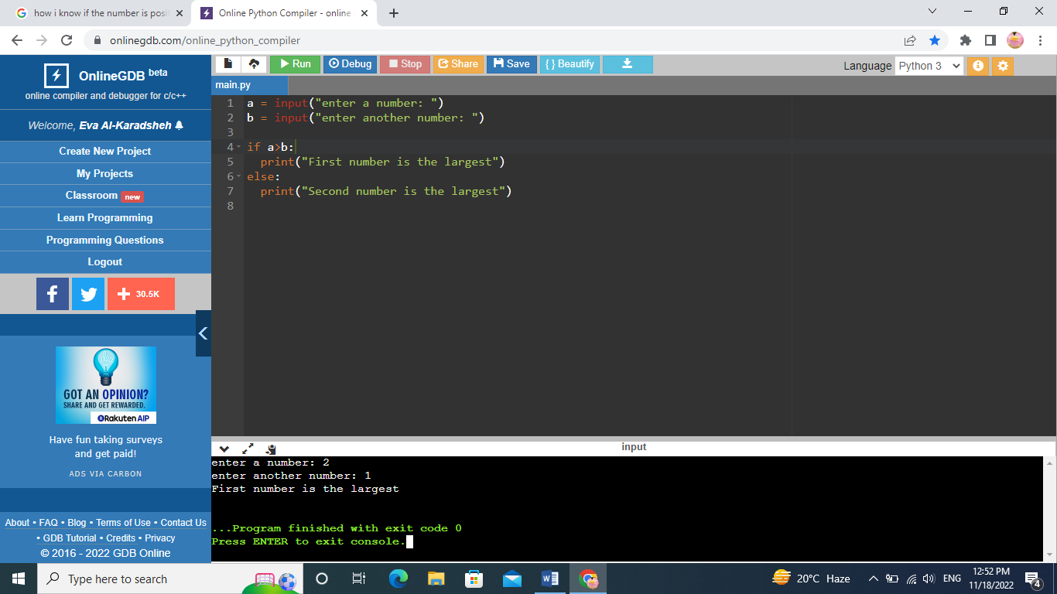

1. **Write a program that print whether a number is odd or even**

**You will need to find the remainder (Mod 🡺 % in python)**

**Mod finds the reminder of the division**

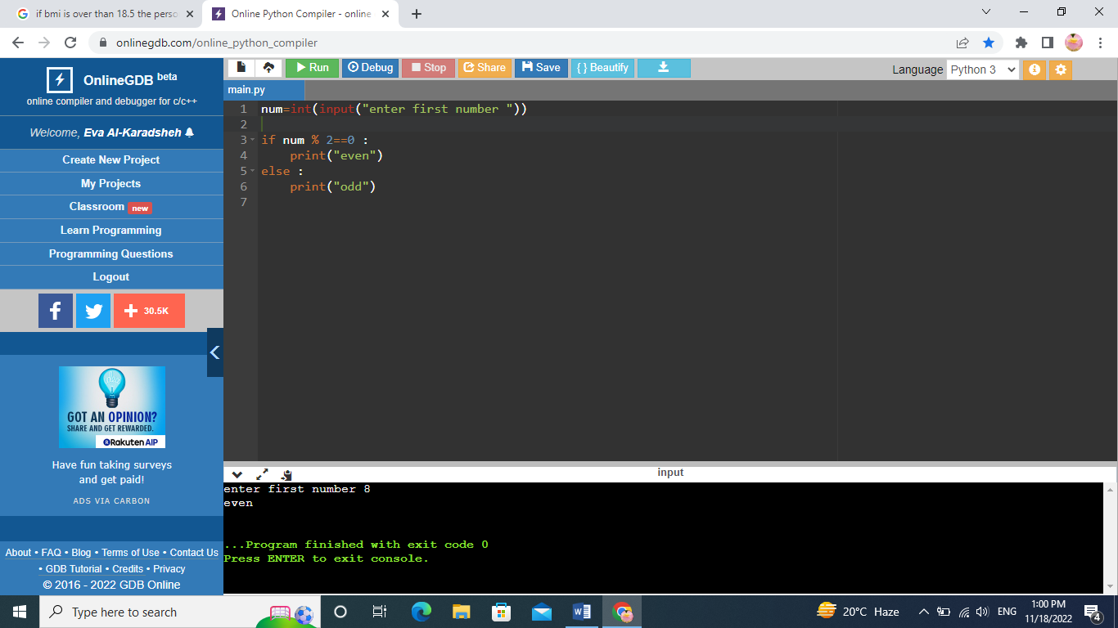

1. **Write a program that:**
   1. **Input your name.**
   2. **Print your name.**
   3. **Input your birthyear**
   4. **Calculate your age.**
   5. **If your age is greater than 18 print (“I’m Adult)   
      else print (I’m child)**

