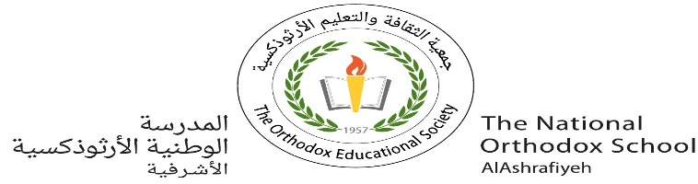

The National Orthodox School

Science Worksheet

**Unit 4 /Atoms and molecules**

Name : Grade: 5 (A+B)

Date: / 11 / 2022

# **Part A: Structure of an atom**

1. Draw four protons in the nucleus of the atom.

label them with their charge.

1. Draw two neutrons in the nucleus of the atom.
2. Draw two electrons in the first energy orbit

and label them with their charge.

4. Circle the correct answer.

1- All matter is made up of atoms.

1. True
2. False

2. What particle is found in the nucleus and has no charge?

1. Electron
2. Neutron
3. Proton
4. Atom

3. The atomic particle with a negative electrical charge is the .

1. proton
2. neutron
3. electron
4. ion

# **Part B: States of matter**

**States of matter**

Matter can be found in three forms or states.

:Screen shot 2013-10-02 at 11.57.25 AM.png Solid

* Atoms have fixed (definite) shape, and they are tightly packed to each other.
* We can feel them, and they can be cut and shaped.
* Atoms vibrate and have strong attraction
* Ex: sand , ice cubes , a piece of iron

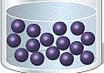

Liquid

* Atoms don’t have fixed shape (indefinite ) shape, they are slightly packed to each other.
* Liquids take the shape of the container.
* Liquids can flow and poured
* Ex: water, milk, juice

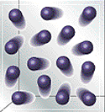

Gas

- Gases have indefinite shape, and take the shape of container

- Atoms are very apart from each other.

- They can spread.

- Atoms move freely in all directions.

Ex: air, oxygen , perfume, steam(Water vapor), smoke

|  |  |  |  |
| --- | --- | --- | --- |
| **Property** | **Solid** | **Liquid** | **Gas** |
| **Shape** | fixed | Don’t have fixed shape | Don’t have fixed shape |
| **molecules arrangement** | Very close to each other.  Particles are tightly packed. | Not very close to each other. | Particles are very far away from each other |
| **Movement of molecules** | vibrate | Move around each other and can flow | Move quickly in all directions and spread |

* 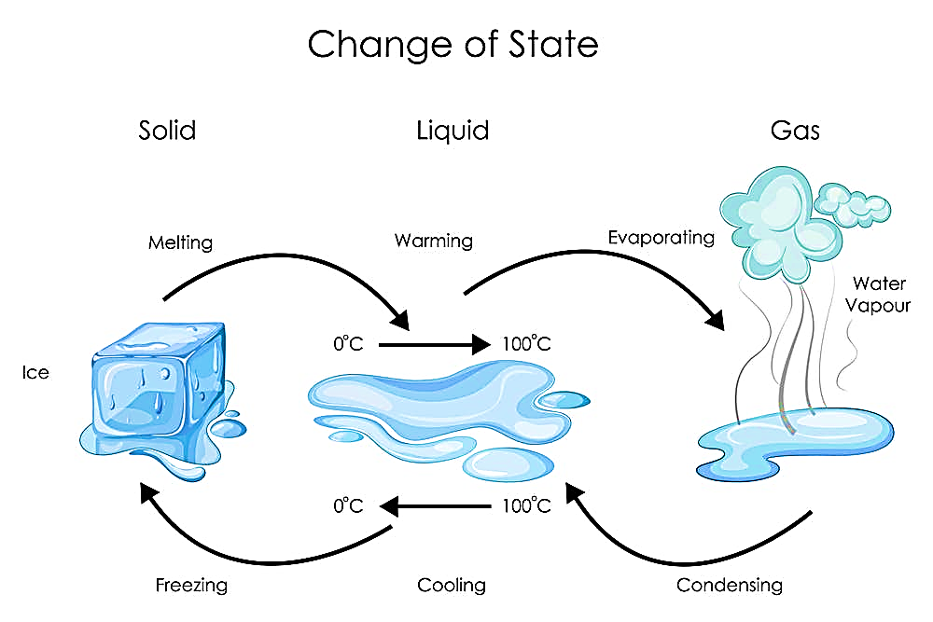**Matter can change its state by heating or cooling.**

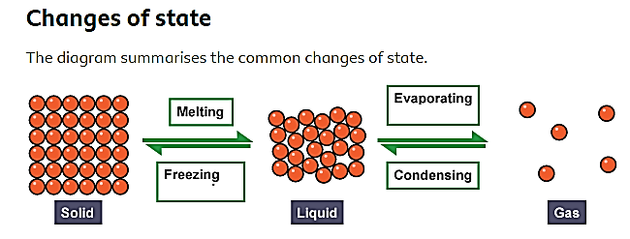

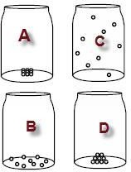Answer the following questions:-

1. The circles in the bottles represent the same particles

of matter. Which pattern of particles represents a gas in a bottle?

1. 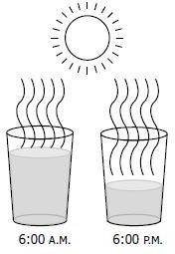When an ice cream is left out of a freezer, the ice cream will change from _________________ to ________________.
2. The process shown would be classified as ______________

4. A gas has no fixed__________ and no fixed_______________.

5. Water vapor is water in ______________ state of matter.

# **Part C: Elements and Compounds**

Remember that an **element** is made up of **only one kind** **of atom**.

A **compound** consists of **two or more elements.**

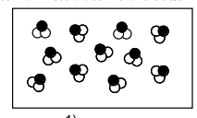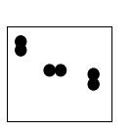Classify each of the pictures below by writing **Element** or **Compound**

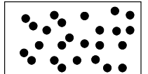

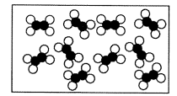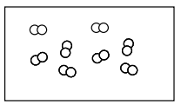

2- Classify each of the following as elements (E), compounds (C)

__________ Sugar (C6H12O6)

__________ Air

__________ Water

___________ Iron

3- Write the chemical symbols for each of the following elements.

a. Potassium _____________

b. Sodium ______________

c. Mercury ______________

d. Gold ______________

e. Silver _____________

f. Nitrogen ______________

g. Iron _______________

4- Name the chemical elements represented by the following symbols.

Na _____________ K ____________

C _____________ Hg ____________