

**Value*: Saring is caring..***

The National Orthodox School

Science Worksheet

Name: Grade: 3

Date: / /2022

***Unit 7: Force***



A **push** is a force that moves something farther away.

A **pull** is a force that moves things closer to you.

|  |
| --- |
|  |

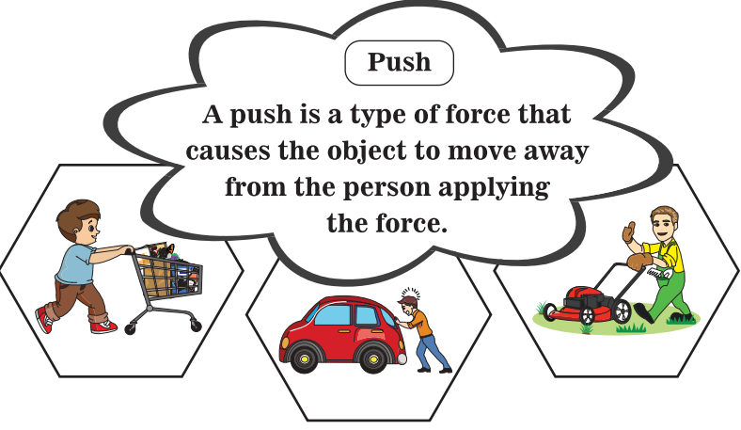

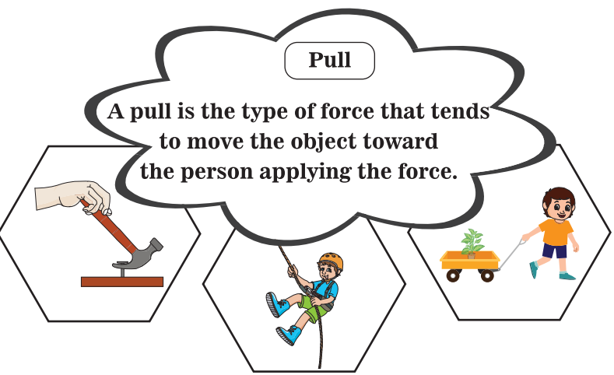

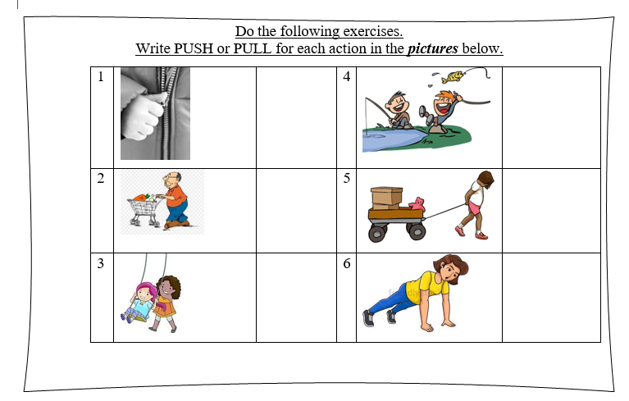

Answer the following questions.

1- Which definition best describes force?

a. **A force is always very strong.**

**b. A force makes things move.**

**2-** A pull moves something away from you: **True or False**.

3- Which sentence is correct?

a**. When you kick a ball, you are using a pull.**

**b. Forces do not make things change direction**.

4- A push moves something away from you: **True or False**