I hope to go to Australia next year.



I plan to learn French soon.



I intend to go shopping at the weekend.

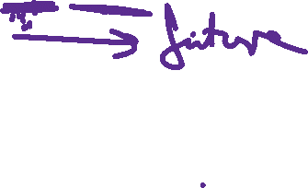

Tense: _________



Refer to: _______

