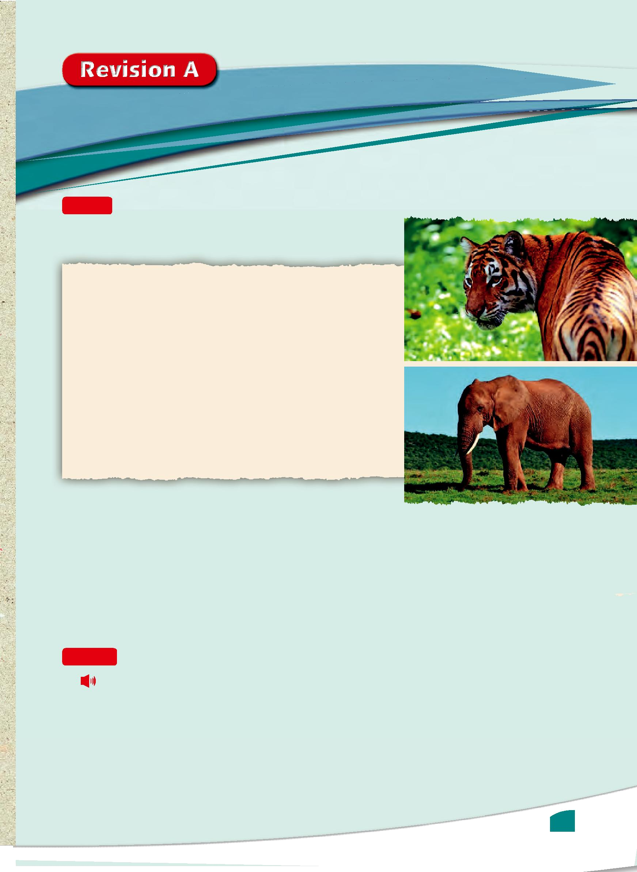

Reading

- Read the beginning of a newspaper article and answer the questions.

A problem for our wildlife

Despite the best efforts of conservation groups and their campaigns, the world’s population of many species, including African elephants, tigers and seals, is still decreasing. It is people’s increasing need for

- land and resources, along with hunting and fishing, which are responsible for this rapid decline in wildlife. Exotic mammals such as big cats are threatened the most, but even common birds and insects in many parts of the world are in danger of dying out forever.

10 According to a report by the World Wildlife Fund and the Zoological Society of London, wildlife populations around the world have been reduced by 52 per cent on average since 1970 CE.

- What evidence is there in the text that attempts have been made in the past to stop the decline in the wildlife

population?

2 Name three reasons for the disappearance of many animals around the world.

- Which species is the most endangered? Which of the reasons, in your opinion, apply to this species in particular?

- ‘More than half the world’s wildlife has disappeared in the last fi fty years.’ Is this statement correct? What evidence is there for this claim?

Listening

2 | Listen to the rest of the newspaper article and answer the questions.
1 | Name two examples of how the world is running out of natural resources.
2 | Choose the correct meaning of a ‘wake-up call’.
 | a an alarm clock b a warning c a telephone call d a danger
3 | What do the authors of the report hope to achieve? There are two possible answers.

41





Vocabulary and grammar

- Choose the most suitable item from the words in the box to complete the sentences. One word is not needed.

4

5

 | sustainability |  | apparatus physician mortality prosthetic
1 | After our Science lesson in the laboratory, we always help the teacher to put the |  |  |  |  |  |  |  | apparatus | away.
2 | The nature reserve uses recycled water, which helps the |  |  |  |  |  | sustainability | of the environment.
3 | Athletes with |  | prosthetic | legs can take part in the Paralympics.
4 | Professor Badari, aged 67, is the hospital’s leading |  |  |  | physician |  | specialising in cancer care.

Choose the correct option in brackets to complete the following sentences.

1 | Many instruments that are still used today in |  |  |  |  |  |  |  | were designed by Arab scholars.
 | (operational / operate / operations)
2 | When do you |  | to receive your test results? (expect / expectancy / expectantly)
3 | When we were younger, we |  |  |  |  |  | live in a village. We moved to the city when I was
 | about ten years old. (were used to / use to / used to)
4 | By the end of this year, we |  |  |  |  | here for ten years. (will live / will be living / will have
 | lived)

Complete the second sentence so that it has the same meaning as the first.

1 | He has written many books, but his final book made him famous all over the world.
2 | He has written many books, but it |  |  |  | was/is his final book that made him famous all over the world. |  | .
2 | He started studying at 5 p.m. It’s 10 p.m., and he’s still studying.
3 | He |  | has been studying | since 5 p.m.
3 | It is normal for me now to get up early to study.
 | I am |  |  |  | .
 |  |  |  | u | .

Used to getting up early to study

Speaking

6 Your local health centre has been given a large donation and they want to use it to improve the facility. Here are some ways in which it could be improved:

• a cafeteria • disabled access • a nutrition centre • a new swimming pool

Discuss with your partner the advantages and disadvantages of all the possible facilities. Decide which two facilities are the most useful.

Writing

- Edit the following text. There are two grammar mistakes and three punctuation mistakes. Find and correct them.

Scientists will say that exercise is not only important for general fitness; but that it is also good for the brain, it helped us concentrate better? As a result, we perform better in exams.

- Write a four-paragraph essay agreeing or disagreeing with the statement below.

‘Large-scale building projects are certainly a necessity in the development of the modern world.’

42

