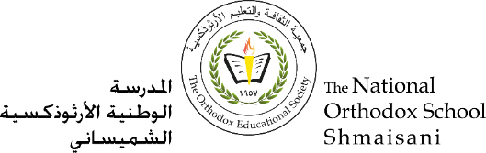

**The Primary Stage (4-5)**

**School Year 2022-2023**

**Name** : ___________ **Subject** : English Language

Writing a fable worksheet# 1

**Date : / / Class : Grade 5CP(C, D, E, F, G)**

**_____________________________________________________________**

**Writing a Fable**

**Objective/s:**

* **Distinguish different features of a fable.**
* **Apply the narrative (fable) structure to the students’ own writing.**
* **Write a fable.**

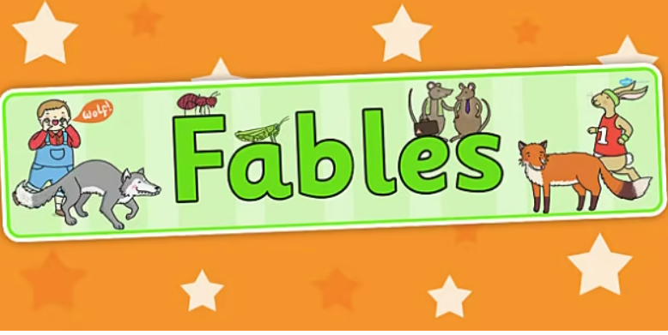

A fable is a tale, mostly short, that teaches a lesson. Often, fables conclude with a moral that summarizes the lesson in plain language. Fables have been around for thousands of years; Aesop, the ancient Greek, is the most famous example. Because they are found in different cultures around the world, fables are a good way to learn about what virtues are important to a given culture.

**Feature of fables:**

* The stories have a moral lesson.
* 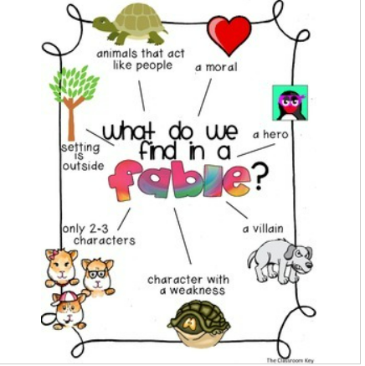The setting and time are vague as it is not important.
* The stories are obviously fictitious – the action never took place.
* Usually the main characters are named in the title.
* Main characters are often animals.
* Simple, concise language is used.
* Connectives are used to show cause and effect.
* Connectives are used to show chronological order.
* Formulaic beginnings introduce the setting and main characters quickly.
* Simple dialogue between two main characters.

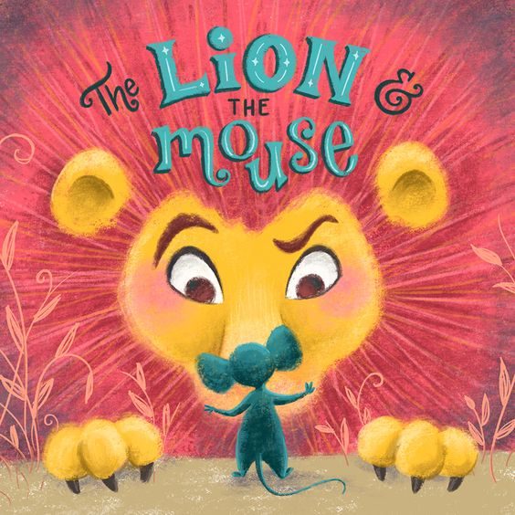

**The Lion and the Mouse**

**A** Lion lay asleep in the shady forest, his great head resting on his paws.

A timid little Mouse came upon him unexpectedly, and in her fright and haste to getaway, she ran across the Lion’s nose. Roused from his nap, the Lion laid his huge paw angrily on the tiny creature to kill her.

“Spare me!” begged the poor Mouse. “Please let me go and someday I will surely repay you.”

The Lion was much amused to think that a Mouse could ever help him. He laughed so hard that the whole ground shook. But as he was a generous Lion, he let the poor creature go.

Some days later, while stalking his prey in the forest, the Lion was caught in the toils of a hunter’s net. Unable to free himself, he filled the forest with his angry roaring. The Mouse knew the voice and quickly found the Lion struggling in the net.

Running to one of the great ropes that bound him, she gnawed it until it parted, and soon the Lion was free.

“You laughed when I said I would repay you,” said the Mouse. “Now you see that even a Mouse can help a Lion.”

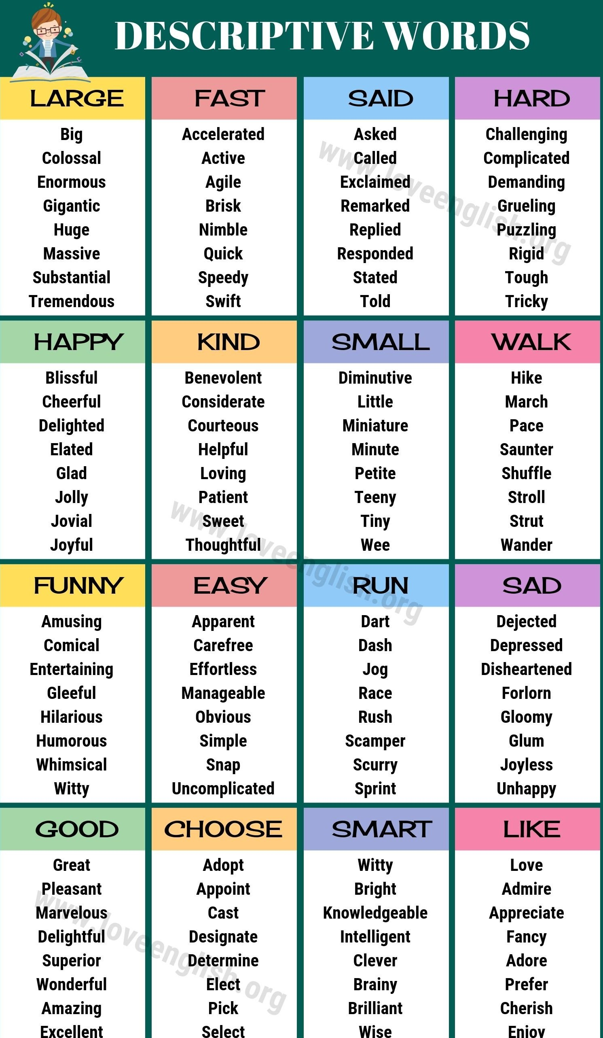

**REWRITE** the fable using a Mouse in the role of the strong animal. What sort of weak animal would you need to make the story work? How would the trap be different? Examples:

* An Ant saves a Mouse from a snapping trap.
* 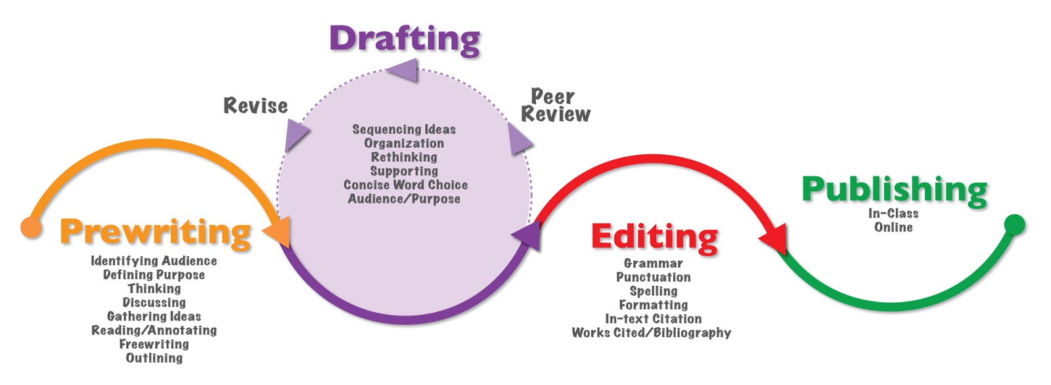A Spider saves a Mouse that has fallen into a jar of honey.

**______________________________**

_______________________________________________________________________________________________________________________________________________________________________________________________________________________________________________________________________________________________________________________________________________________________________________________________________________________________________________________________________________________________________________________________________________________________________________________________________________________________________________________________________________________________________________________________________________________________________________________________________________________________________________________________________________________________________________________________________________________________________________________________________________________________________________________________________________________________________________________________________________________________________________________________________________________________________________________________________________________________________________________________________________________________________________________________________________________________________________________________________________________________________________________________________________________________________________________________________________________________________________________________________________________________________________________________________________________________________________________________________________________________________________________________________________________________________________________________________________________________________________________________________________________________________________________________________________________________________________________________________________________________________________________________________________________________________________________________________________________________________________________________________________________________________________________________________________________________________________________________________________________________________________________________________________________________________________________________________________________________________

FABLE EDITING CHECKLIST

|  |  |
| --- | --- |
|  |  |
|  | My fable includes an animal that takes on human characteristics. |
|  | My fable has a beginning that introduces the characters, setting, and conflict. |
|  | My fable includes a middle that allows my character to encounter the conflict and begin to search for a way to fix the problem. |
|  | My fable includes an end that allows my character to find a solution. |
|  | My fable teaches an important moral. |
|  | The events of my fable lead logically to the moral. |
|  | I have used plenty of detail in telling my fable. |
|  | I have read over my work at least three times. |
|  | I checked spelling and fixed the words that didn’t look right. |
|  | I have re-read my written piece aloud to see where to stop or pause for periods, question marks, exclamation marks, and commas. |
|  | Capitals have been used where needed. |
|  | I have used quotation marks around the words that a character is speaking. |
|  | My final draft is neatly handwritten or typed. |
|  | I have included an illustration for my fable. |

