

**Our value: Alone we can do so little; together we can do so much.**

**Homonyms**

**Name………………… Grade (6)**

|  |
| --- |
| **Objectives**  **To identify what a homonym is and learn a group of exmples.** |

**Homonyms** are two words that are spelled the same and sound the same but have different meanings.

A simple example of a homonym is the word "**pen**." This can mean both "a holding area for animals" and "a writing instrument." Another example is "**book**," which can mean "something to read" or "the act of making a reservation." In both cases, the sound and spelling are the same, and only the definition changes. Examples:

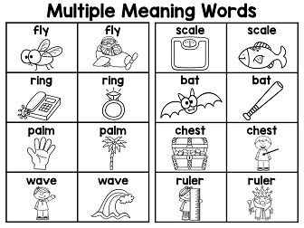

|  |  |  |  |
| --- | --- | --- | --- |
|  | | | |
| **Homonym** | **Part of Speech** | **Meaning** | **Sentence Example** |
| Bear | Noun | A large, wild animal | They saw a black **bear.** |
| Verb | Being able to accept and deal with something | You will have to **bear** the pain. |
| Right | Adjective | Correct or true | You are **right.** |
| Noun | The right side | Meena sat on the **right.** |
| Adverb | Correctly or exactly | Everything that you told us was **right.** |
| Tear | Noun | A drop that comes from your eye when you cry | She had **tears**in her eyes at the end of the movie. |
| Verb | To pull something apart in pieces and damage it | The little girl will **tear** up everything she gets. |
| Match | Noun | A game | Do you know which team won the **match?** |
| Noun | A small stick used to start a fire | I used a **match**to light up the stove. |
| Verb | To find something that is suitable | My mom was looking for a lining material that **matches** the pastel-coloured saree she bought recently. |
| Ring | Noun | A jewel that you wear on your finger | My father bought me a diamond **ring** |
| Noun | A round object | I used a **ring**to make a dreamcatcher. |
| Verb | To call someone | Manu will **ring**you in some time. |
| Verb | To cause something to sound like a bell | Did you hear the bell **ring?** |
| Kind | Noun | A group of people with similar characteristics | We are one of a **kind.** |
| Adjective | Being good, generous, helpful | Beena is very **kind.** |
| Lie | Noun | Something untrue | I think she is telling a **lie.** |
| Verb | To quote something untrue | My mom does not **lie.** |
| Verb | To rest | He is **lying**on the bed. |
| Bright | Adjective | Strong, full of light | The sun is very **bright** today. |
| Adjective | Intelligent, clever, learning quickly | Aarathi is a **bright** student. |
| Address | Noun | The name and number of a building, the location of a building | Sherly gave her **address** so that we would not lose our way. |
| Verb | To write or speak to someone | Today, Susan will be **addressing**the first-year students. |
| Watch | Noun | A device to check the time of the day | I bought a new **watch.** |
| Verb | To see or look at something | Can you please **watch**the baby for an hour? |

**\*Look at the pictures, cut the words and stick them under the correct pictures.**

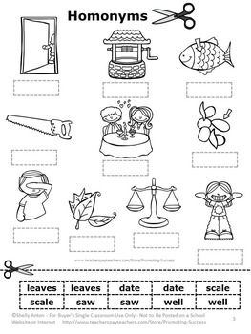

leaves

scale

well

date

date

saw

saw

scale

well

leaves

What does the underline word mean.

1. Put the shoe on the right foot. The right side

2. Two wrongs don’t make a right. Correct or true

3. A kind word is never lost. Good

4. What kind of house do you live in? A group of things with similar characteristics

5. I cannot find my watch; I must have lost it. A device to check the time of the day.

6. Come round tonight and we'll watch a video. To see or look at something.

**Teacher: Mirna Nawaf Al-Sahawneh**

**Coordinator’s signature: ---------------------**