**A Friendly Email (Informal Email)**

These are usually to your friends or family, and in this writing task you will be asked to write about specific bullet points that are mentioned in the task description.

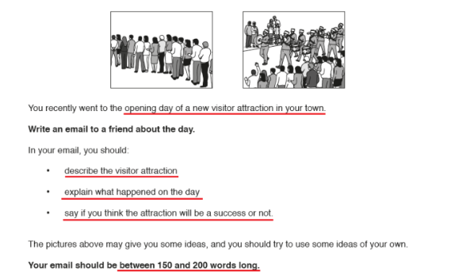

* You must be familiar with the **format** of an informal letter:
* Salutation (Dear/Dearest.).
* Introduction.
* Body (maybe two paragraphs).
* Conclusion.
* Signature (With Love/Yours Truly/ Your sincerely)  
  The **salutation and signature** are simple. What about the others? Let’s take a look.

**Introduction:**

* Start with a warm, friendly opening. Ditch the boring **‘How are you doing? ‘.** Go for these:

**It was good to hear from you. Sorry for not replying sooner. I have been very busy.**

**I’m so sorry for taking so long to reply. I have been revising for my exams.**

**Congratulations on your award! It’s been a hectic week over here. So sorry I couldn’t write to you earlier**

* Tell them why you’re writing the letter. This will be specified in the question paper itself. Keep it very short. In the example above, you could say: **I’ve been dying to tell you about this circus that came to town last Friday!**

**Body**:

This is the actual content of your letter. Provide more details about the topic. Use **lots of adjectives and verbs** and really relay your **thoughts and emotions**. **Use the prompts and pictures** in the question. You can write it in t**wo paragraphs** to organize your ideas.

In the example above, you could write:

Nobody knew about the circus arriving. But the moment they opened the entrance, all the villagers started flocking in.  Steve and I begged for mom and dad to take us there! It was magnificent, in every sense of the word! There were talking parrots, tigers jumping through fire hoops (Steve ran away scared when he saw the Tiger!), an elephant that could predict your weight, a fortune teller and all sorts of things you see in the circuses in movies!

Mom was fascinated by the ‘Guess the Price’ tent and spent a lot of money on it but didn’t guess a single one right. Dad and I went to every single tent. My favorite was this magic show! The magician literally turned a rat into a rabbit! I have no idea how.  It was truly magical! We stayed there till dusk and then very reluctantly went back. The circus clearly had won the hearts of all villagers.

**Conclusion**:

The conclusion has to wrap up the letter. For example, **I really wish you were there! You would have loved it! Give my regards to Margret and Aunt Marie! Reply soon!**

**TIPS**

* Take care of **spelling, punctuation and grammar**. It’s a writing task after all.
* **Don’t use abbreviations and slang** such as ‘u’ and ‘OMG’! This is an exam, not an actual email to your friend!
* Keep the **tone very light and warm**. An informal letter should be informal.
* Writing a**paragraph for each bullet point** (given in the question) can be a good method of keeping the letter organized.
* **Give personal anecdotes**. Add details in order to show that you really know each other. In the sample writing above, we used the names *Steve*, *Margaret* and *Aunt* *Marie* without giving any explanation for who they exactly are, because my friend knows who they are! Unless the task was about some that the receiver of the letter doesn’t know about.
* Try using**time phrases.** E.g.:**shortly after that/later/that afternoon/after dinner etc.**
* Try using very well- known idioms. E.g.: **Break a leg**
* **Keep to the word limit**. It should be at least 150 words and shouldn’t exceed 200 words.

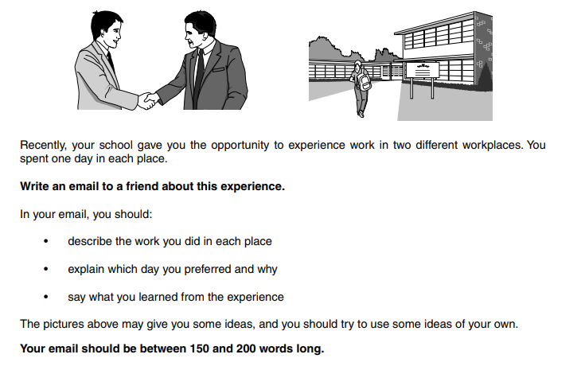

Now write your email in the following page.

Dear Anna. …………………………………………………………………………………………………………………………………………………………………………………………………………………………………………………………………………………………………………………………………………………………………………………………………………………………………………………………………………………………………………………………………………………………………………………………………………………………………………………………………………………………………………………………………………………………………………………………………………………………………………………………………………………………………………………………………………………………………………………………………………………………………………………………………………………………………………………………………………………………………………………………………………………………………………………………………………………………………………………………………………………………………………………………………………………………………………………………………………………………………………………………………………………………………………………………………………………………………………………………………………………………………………………………………………………………………………………………………………………………………………………………………………………………………………………………………………………………………………………………………………………………………………