

**The Primary Stage (4-5)**

**School Year 2022-2023**

**Name :** ____________  **Subject : Simple Past Tense Worksheet**

**Date : / / 2022**  **Class : Grade 5Nat.A+B**

**­­­__________________________________________________________**

Remember:

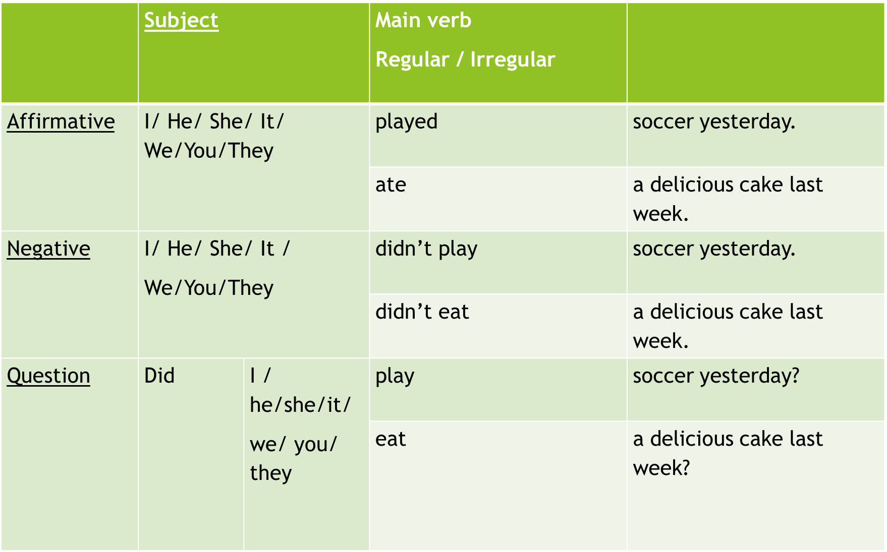



**Q1. Fill in the blanks below to complete the sentences.**

1. I (eat) ___________ dinner at six o’clock yesterday.

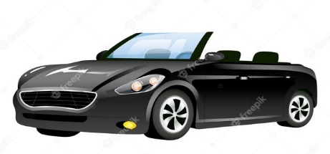2. A: ___________ Helen (drive) ___________ to work? B: Yes, she ___________.

3. My neighbor (buy) ___________ a new car last week.

4. They (go) ___________ to Italy on their last summer holiday.

5. A: ___________ they (swim) ___________ at the beach?

B: No, they __________.

6. My family and I (see) ___________ a comedy movie last night.

7. First, we (do) ___________ exercise, and then we (drink) ___________ some water.

8. Suddenly, the animal jumped and (bite) ___________ my hand.

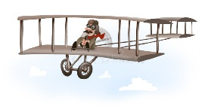9. What time (do) ___________ you (get up) ___________ this morning?

10. The Wright brothers (fly) ___________ the first airplane in 1903.

11. I think I (hear) ___________ a strange sound outside the door one minute ago.

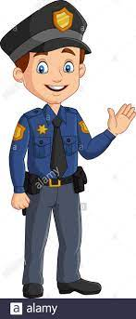12. When I was ten years old, I (break) ___________ my arm. It really (hurt) __________.

13. The police (catch) ___________ all three of the bank robbers last week.

14. How many times (do) ___________ you (read) ___________ that book?

**Q2. Change the following sentences in negative sentences and questions.**

1. Jana went to the mall last week.

___________________________________________________________.

__________________________________________________________?

2. The boys broke the window two days ago.

___________________________________________________________.

__________________________________________________________?

**Q3.Write these sentences in the past.**

1. He goes to the swimming pool because he likes swimming. ___________________________________________________________

2. They have dinner at nine o´clock. ___________________________________________________________

**Q4.Change the verbs in brackets into the past tense. Some are regular and some are irregular.**

Yesterday (to be) _______________ a busy day. I (wake) _______________ up at 6am, (have) _______________ breakfast quickly and then I (go) _______________ to work. I (finish) _______________ at noon and then (eat) _______________ some lunch. Afterwards I (drive) _______________ to the shops, (buy) _______________ some paint and then (paint) _______________ my bedroom. My housemate (come) _______________ home from work so I (help) _______________ him paint his room, then we (repair) _______________ his chair as it (wobble) _______________ a lot. I (wish) _______________ I hadn’t, as I hurt my hand! After that I (clean) _______________ my house. I (vacuum) _______________ all the downstairs and then (tidy) _______________ up the living room and the kitchen. I was pretty tired by then so I (eat) __________ some dinner, (yawn) _______________, and (go) _______________ to bed!

**Q5. Write a short paragraph about what you did last weekend.**

**_______________________________________________________________________________________________________________________________________________________________________________________________________________________________________________________________________________________________________**

**___________________________________________________________**

**Q6. Write the Past Simple form of the verbs below in the correct column.**

|  |
| --- |
| repeat - worry - finish - start - phone - call - miss - enjoy - visit - marry -listen cry - play - hate - wash - climb - live - arrive - talk - look - stay - ask - clean - travel -open - like -walk - carry - stop - mix - plan - decide - tidy |

|  |  |  |  |
| --- | --- | --- | --- |
| -d | -ed | Cons+y = ied | Double cons + -ed |
|  |  |  |  |

**Remember:**

**We use WERE when the subject start with we, they, you or plural nouns.**

**Examples:**

**They were hungry.**

**The children were studying Math when the storm started.**

**We use WAS when the subject starts with she, he, it , I or singular nouns.**

**Q8. Complete the following using WAS or WERE.**

1. She _______________ hoping her mother would come home early today.

2. The children ___________________ having fun in the pool today.

3. The movie ______________________ excellent and the children __________ very good.

4. The questions on the math test ___________________ very tricky!

5. You _________________ supposed to wash the dishes today.

6. I __________________ supposed to wash the dishes today.

7. I wish it ____________________ spring again.

8. He behaves as if he ___________________ the teacher!

9. ________________________ there many people at the game?

10. When she __________________ young, she ___________________ a great dancer.

11. I ____________________ hoping to pass my spelling test.

12. Who ______________________ you playing with at school today?

13. Why ______________________ he so upset with you?

14. I knew they ____________________ going to England this summer.

**Q9. Find and correct the mistakes in the following sentences.**

1. Roy tidyed his room on Friday. ____________________

2. They danceed a lot at the party last night. ________________

3. Two years ago, my parents boght a new car. _______________

4. My sister and her cousin comed from Greece. _______________

5. Alex didn’t washed the car last night. __________________

6. Did she went to Paris last year? ________________