

**The Primary Stage (4-5)**

**School Year 2022-2023**

**Name :** ____________ **Subject : Simple Present Tense Worksheet**

**Date : / / 2022**  **Class : Grade 5Nat.A+B**

**­­­__________________________________________________________**

|  |  |  |  |  |
| --- | --- | --- | --- | --- |
|  | **Subject** | | **Main Verb** |  |
| Affirmative | I/ We/You/They | | go | to bed early. |
| He/ She/ It | | goes |
| Negative | I/ We/You/They | | don't go | to bed early. |
| He/ She/ It | | doesn't go |
| Question | Do | I/ we/you/they | go | to bed early? |
| Does | he/she/it |

Remember:



**Q1. Fill in the blanks below to complete the sentences using simple present tense.**

Peter (1) ________________ (start) his day at 7.oo. He (2) ______________ (have) breakfast in the kitchen with all the family. Each member (3) _______________ (fix) his own breakfast. Peter (4) _________________ (like) orange juice, toast and milk. He always(5) __________ (have) an apple: his mother (6)_______________ (believe) “an apple a day (7) __________ (keep) the doctor away”. After breakfast Peter (8) ____________ (make) his bed and (9) __________ (tidy) up his bedroom. He (10) __________ (get) ready for lessons. He mustn’t be late, mother (11) __________ (be) very strict.

At 8.00 the Hanson kids (12) __________ (start) their lessons. At midday they (13) __________ (have) lunch. Then it’s sport time: they (14) __________ (love) playing basketball, in-line staking and skate-boarding. After a refreshing shower the Hanson brothers (15) __________ (rehearse) till dinner, because their fans (16) __________ (be) very demanding: they (17) __________ (want) every detail to be OK.

Peter and his brothers (18) __________ (not/have) dinner with their parents as their father is always late. Their mother (19) __________ (not/like) it very much. So, at weekends they (20) __________ (be) always together.

**Write a short paragraph about your daily morning routine.**

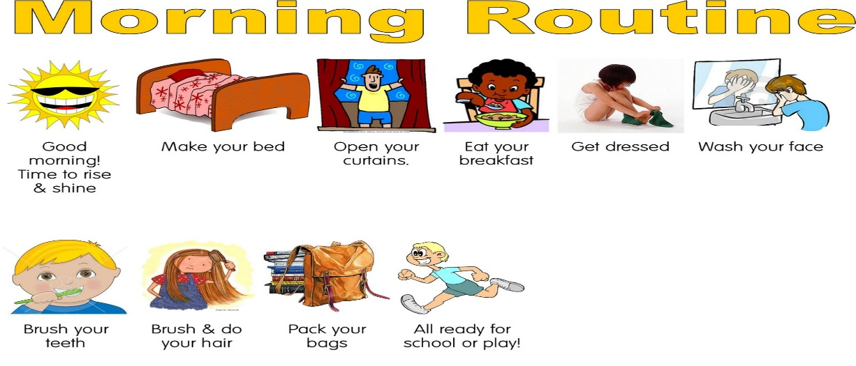----------------------------------------------------------------------------------------------------------------------------------------------------------------------------------------------------------------------------------------------------------------------------------------------------------------------------------------------------------------------------------------------------------------------------------------------------------------------------------------------------------------------------------------------------------------------------------------------------------------------------------



**Q2.Change the verbs in brackets into the simple present tense.**

1. Supermarkets ----------------- (open) at 8 o’clock and --------------- (close) at 9.

2. Every morning Jackson -------------------- (turn) on his computer and ------------------ (check) his Facebook for updates and news.

3. Our school ---------------------------------- (usually/have) breaks in the morning and afternoon.

4. Our flight ------------------------------ (leave) at 9 in the morning.

5. School ----------------------- (start) in September and ---------------------------- (finish) in June.

6. I usually ---------------------- (go) to school.

7. They ---------------------- ( not/ visit) us often.

8. You ----------------------------- (play) basketball once a week.

9. Tom ------------------------- (not/ work) every day.

10. He always ------------------------------ (tell) us funny stories.

11. She never ---------------------------------- (help) me with that!

12. Martha and Kevin --------------------------------- (swim) twice a week.

13. In this club people usually ---------------------------- (dance) a lot.

**Q3. Complete the questions with *Do or Does*.**

1. -------------------------- she take her dog for a walk in the morning?

2. ------------------------ your friend Paul work in the shop over there?

3. ------------------------------ they know the answers to the exam?

4. --------------------------- your parents know that you smoke?

5. --------------------------- Bill teach maths?

6. Where ------------------------ your sister live?

7. What time -------------------------- the lessons finish?

8. ------------------------- you go to the coast in summer?

9. ---------------------- it rain very often in Ireland?

10. Why ---------------------- they ask so many questions in class?

**Q4. Write short answers to these questions**

1. Do you speak French? _____________________

2. Does your father work? _____________________

3. Does your mother like chocolate? _____________________

4. Do you go to the cinema? _____________________

5. Do you study a lot? _____________________

6. Does your best friend study? _____________________

7. Do you usually watch TV at night? _____________________

8. Does it rain a lot in Africa? _____________________

**Q5. Choose the correct answer.**

1. David and Suzy ___________________ table-tennis. (play/plays)

2. The little boys ___________________ to school on foot. (go/goes)

3. Carol ___________________ in Canada. (live/lives)

4. School ___________________ at 6.30. (finish/finishes)

5. We ___________________ T.V. in the evening. (watch/watches)

6. Jessica ___________________ in her bedroom. (study/studies)

7. The dog ___________________ in the kennel. (sleep/sleeps)

8. The children ___________________ the street to school. (cross/crosses)

9. Mr. Wilson ___________________ in a bank. (work/works)

10. Joe ___________________ his homework in the afternoon. (do/does)

**Q6. Rewrite the sentences in the: negative and interrogative forms.**

1. Grace has breakfast in the kitchen.

a) __________________________________________________________________.

b) __________________________________________________________________?

2. Mr. Robson drives to work every morning.

a) __________________________________________________________________.

b) __________________________________________________________________?

**Q7. Find the mistakes and then correct them in the following sentences.**

1. Alan don’t like talking to new people. ___________________

2. Carlos make people laugh. ___________________

3. I eats a hamburger every weekend. ______________

4. Who does you play football with? ________________

5. When does your brother surfs the internet? _____________________

6. Do Maria listen to music? ___________________

7. Peter doesn’t studies French.________________

**Q8.Read the paragraph. Find and correct five more errors with the simple present.**

Bill is a mechanic. He know a lot about cars. He work at a garage. He fix cars and talks to customers. They asks questions about their cars. Bill works from 8:00 a.m. to 6:00 p.m. every day. He haves a busy schedule, but he like his job very much.

-------------------- -------------------------- -------------------------- ------------------------------ --------------------------

**Q9. Put the words in the correct order to make sentences. (Simple Present Tense)**

**Example:**

**1. Saturday / to / work / They / need / on**

**They need to work on Saturday.**

2. He / have / lunch / wants / at / 1:00 / to

______________________________________________________________

3. tonight / to / need / work / until / 7:00 / You

______________________________________________________________

4. need / buy / I / to / computer / a / new

______________________________________________________________