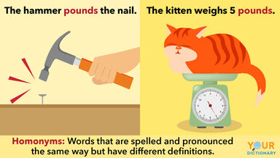

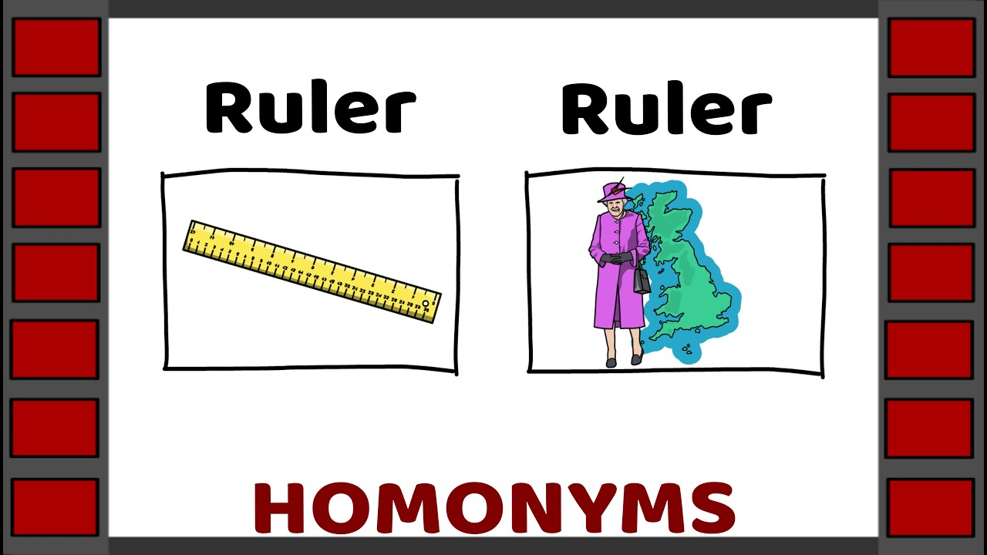

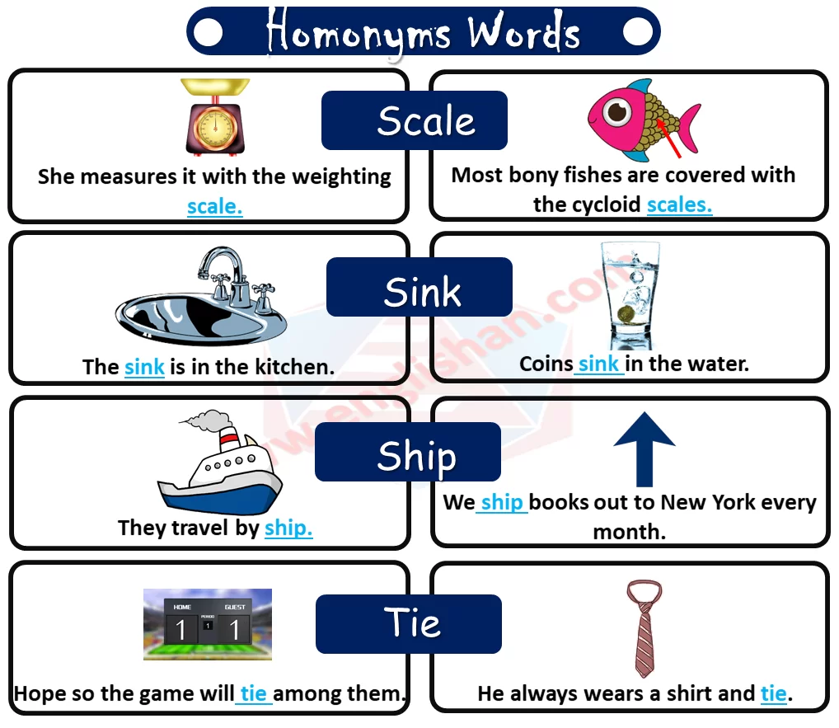

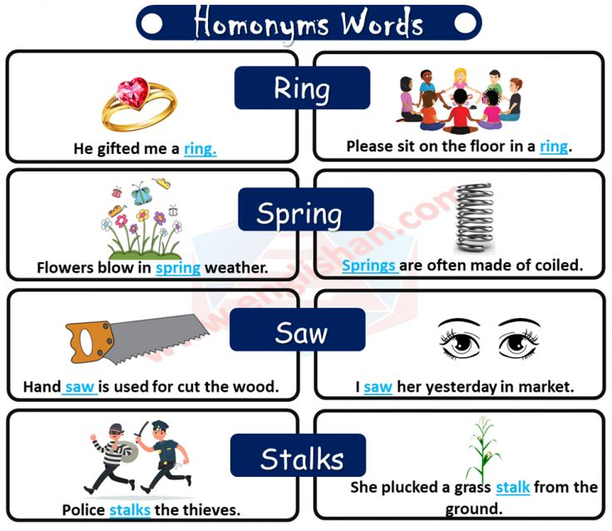

|  |
| --- |
| 1.You have to take a right turn to reach that supermarket.  2: Her decisions are often right. |
| 5. Bear are animals that are of black and white color.  6. He had not to bear that much pain before.  7. He can play the flute.  8. He wants a Pepsi can. | 3: Rahul is going to buy a diamond ring for his wife.  4: Don't forget to ring me before you come home. |

