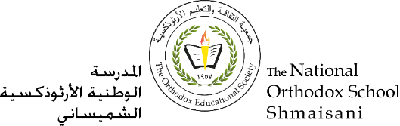

**The Primary Stage of Grades (4-5)**

**School Year 2022- 2023**

**In the name of the Father, the Son and the Holy Spirit**

**Name**: ___________ **Subject**: **worksheet N.3**

**Date : / / Class: Grade Five**

**The Lord’s Prayer**

**Q1: What is the meaning of prayer?**

A1: Prayer is the relationship between man and God by which children speak with their heavenly Father.

**Q2: Why do we call God our Father?**

So that we know that God is our heavenly Father who presents with us in every place and time.

**Q3:** **What commandment does God give us to forgive our sins and forgive us?**

**“**For if you forgive other people when they sin against you, your heavenly Father will also forgive you”.

**Q4: Why does Lord Jesus Christ ask us to forgive each other?**

So that He forgive us when we, too, committed sins.

**Q5: Why is this prayer called the Lord's Prayer?**

Because Lord Jesus Christ himself taught us this pray.

**Q6:** **What do we call God when we pray to Him?**

We call him our father.



**Q7: How many special requests to glorify God?**

Three requests:

* Hallowed by your Name
* Your Kingdom come
* Your Will be done

**Q8: How many special requests are needed for our spiritual and physical needs?**

Four requests:

* Give us today our daily bread.
* Forgive us our depts.
* Lead us not into temptation.
* Deliver us from the evil one.

**God bless you**