

**Modal Verbs No (10)**

Grade 5 ( A + B )

Name: Date : / /

Objectives: To identify certain modals of ability and modals of certainty.

To practise using these modals correctly.

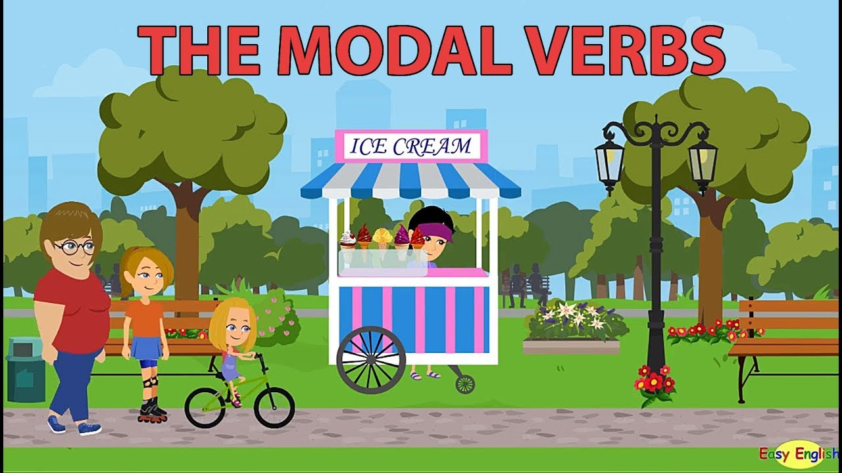

A **modal verb** is a special type of **verb**. **Modal verbs** change or affect other **verbs** in a sentence. They are used to show the level of possibility, indicate ability, show obligation or give permission.

**1. Modals of Ability

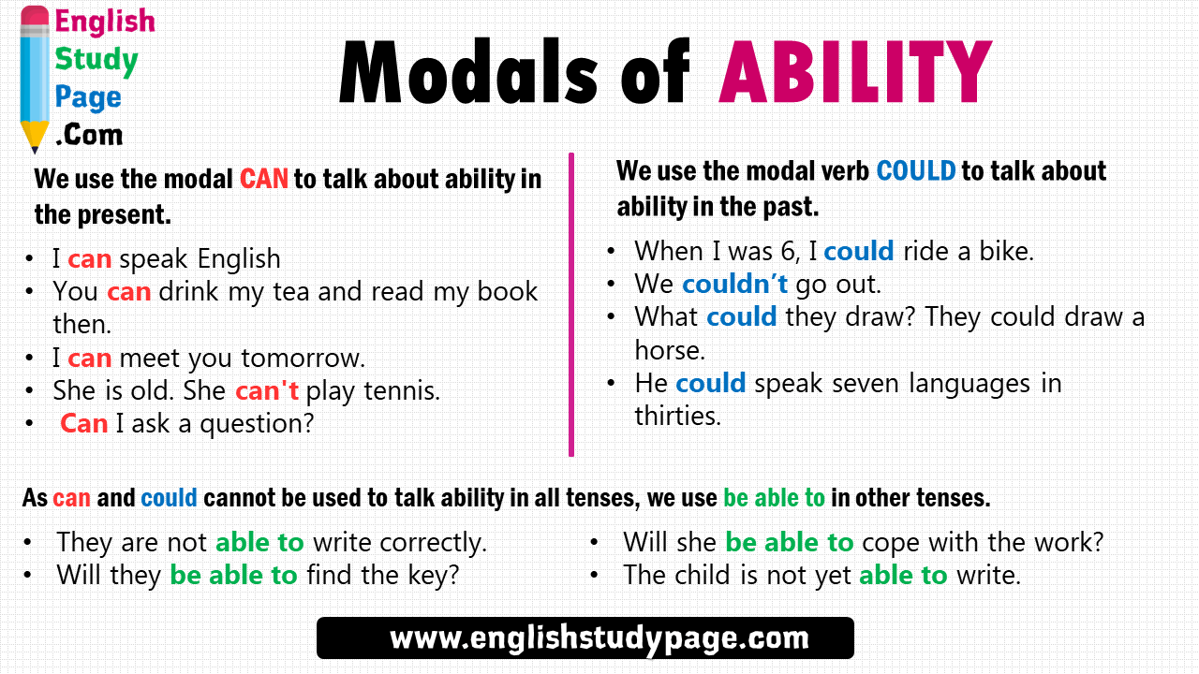

-Remember: use **could** and **couldn’t** to say that you **did** or **didn’t** know how to do something in the past.

Ex:

I could read by the time I was four.

I couldn’t chew after I got a cavity.

**The future of ***can / can’t*** is ***will / won’t be able to***.

Next year, I **will be able to** ride my bike to school. I **won’t be able to** drive a car.

A. Complete the following text using the words from the box below.

could / will be able to / can / couldn’t / won’t be able to / can’t

Toby was very sick yesterday. His stomach hurt and he couldn’t eat any food. He could drink a little water, but he wasn’t very thirsty. He couldn’t play soccer in the park with his friends, so he stayed in bed and read his book. He is feeling a little better today. He can drink a little soup, but he

can’t eat very much. He can’t go to school, because he still feels sick and tired.

Toby has taken some medicine now, so he hopes he will be able to

go to school tomorrow. He wants to eat more food tomorrow, too. Toby’s mother says he won’t be able to have sweet foods tomorrow because they aren’t good for his stomach, but Toby thinks he will be able to eat a small piece of cake!

B. Choose the correct answer.

1. The babies ------------ play football when they are one-year-old.

**a. can’t b. could c. couldn’t d. won’t be able to**

2. Ben ----------- speak when he was three years old.

**a. can’t b. could c. can d. will be able to**

3. I ------------- fly a plane now.

**a. can’t b. could c. couldn’t d. will be able to**

4. We ------------ stay up late when we are adults.

**a. can’t b. will be able c. could d. couldn’t**

5. She ------------ play the guitar when she was four years old.

**a. couldn’t b. won’t be able to c. can’t d. can**

6. We ------------ speak English now.

**a. can b. couldn’t c. won’t be able to d. will be able to**

Teacher: Mirna Nawaf Al-Sahawneh.

Coordinator’s Signature: --------------------------