

**Our value: Alone we can do so little; together we can do so much.**

**Vocabulary _ Unit 3**

**No (9)**

**(The Cavity)**

**Name………………… Grade (5)**

|  |
| --- |
| **Objectives**  **1. Identify the meaning of the new words.**  **2. Identify the synonyms of the new words.**  **3. Practice using the new words in sentences.** |

**Verbs**

|  |  |  |
| --- | --- | --- |
| **Word** | **Meaning /Synonym** | **Example** |
| Scrub | To **clean** by rubbing hard. | Scrub the wood thoroughly with water and a stiff brush. |
| Thrill | To **excite** | If you want to thrill the audience, taking risks is essential. |
| Scurry | To **run** | All the chicks scurry to shelter. |
| Attack | To **beat**. | Brazil began to attack more in the second half of the match. |
| Stray | To **get lost**. | Be careful not to stray from the path. |
| Nibble | To **bite**. | He started to nibble his biscuit. |
| Munch | To **crunch**. | He peeled two more carrots and continued to munch. |
| Slice | To **cut** something into thin pieces. | I’ll slice it for you as thick as you want. |
| Grip | To **keep hold** of someone or something firmly. | The brake doesn’t grip properly. |
| Crush | To **press** someone or something hard so that he/ she/ it is broken, damaged or injured. | They crush the olives with a heavy wooden press. |

**Adjectives**

|  |  |  |
| --- | --- | --- |
| **Word** | **Meaning /Synonym** | **Example** |
| Nasty | **Awful**. | You can get a nasty sting from a jellyfish. |
| Yummy | **Delicious**. | I think I'll have some more of that yummy chocolate cake. |
| Defective | Having a defect or flaw; **imperfect**. | I exchanged the defective tire for a good one. |

**Nouns**

|  |  |  |
| --- | --- | --- |
| **Word** | **Meaning /Synonym** | **Example** |
| Canines | The four sharp, pointed teeth towards the front of your mouth. | His canines were four times the length of hers. |
| Molars | The large flat teeth at the back of the mouth. | The horse softens food before swallowing by chewing the food between his molars with a sideways grinding action of the lower jaw. |
| Jaws | The **bones** forming the framework of the mouth. | The antelope could not escape the crocodile’s gaping jaws. |
| Cavity | A hollow space or a pit in a tooth. / **dent** | I’ve got a cavity right inside my tooth. |
| Incisor | Any of the four anterior teeth in each jaw, used for cutting and gnawing. | The upper incisor teeth are generally marked by grooves. |
| Carnivore | An animal that eats flesh./ **meat-eater** | Danger in the wild comes from the carnivores. |
| Herbivore | An animal that feeds on plants./ **vegetarian** | It is known that attacks on plants by herbivores reduce the quality of the tissues for subsequent feeding. |
| Omnivore | An animal or person that eats a variety of food and of both plant and animal origin./**consumer** | Omnivores are able to eat animal or vegetable food. |
| Prey | An animal that is hunted and killed by another for food./**victim** | The big bird carried its prey in its claws. |
| Treat | A **gift**. | Steven took his son to a cricket match as a birthday treat. |

1. **Write the synonym of each of these words**:
2. Scrub clean
3. Thrill excite
4. Scurry run
5. Attack beat
6. Stray get lost
7. Nibble bite
8. Munch crunch
9. Nasty awful
10. Yummy delicious
11. Defective imperfect
12. Jaws bones
13. Cavity dent
14. Carnivore meat-eater
15. Herbivore vegetarian
16. Omnivore consumer
17. Prey victim
18. Treat gift
19. **Write the correct word under each picture.**

|  |
| --- |
| Gum _Crush _ Grip _Slice_ Scrub _Thrill _ Scurry _ Attack _ Stray _ Nibble Munch _ Nasty _ Yummy _ Defective _ Canines _ Molars _ Jaws _ Cavity Incisor _ Carnivore _ Herbivore _ Omnivore _ Prey _ Treat. |

 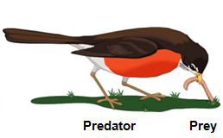 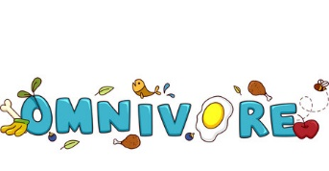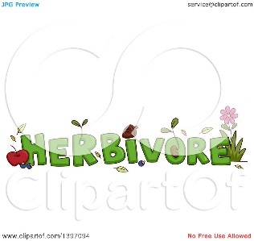

Treat prey omnivore herbivore

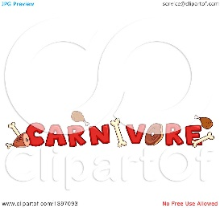 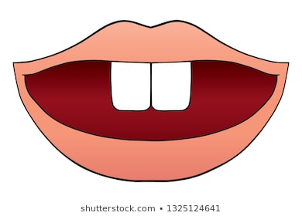 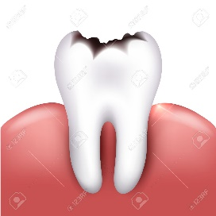 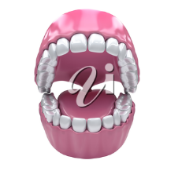

Carnivore incisor cavity jaws

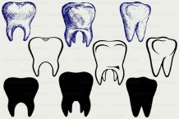 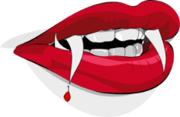  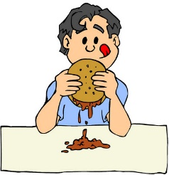 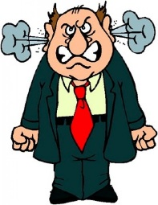

Molars canine defective yummy nasty

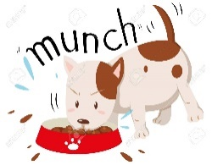 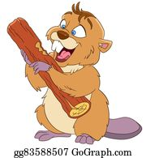  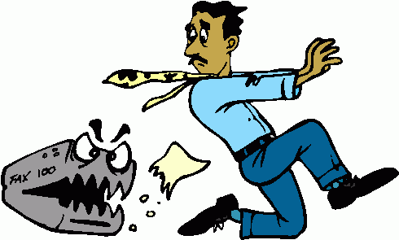

Munch nibble stray attack scurry

 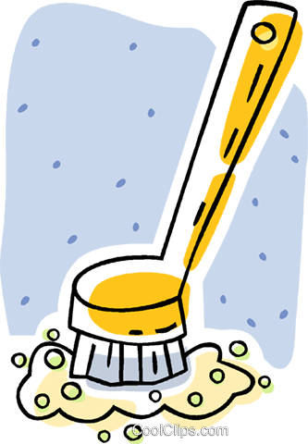 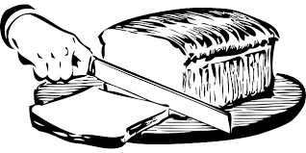 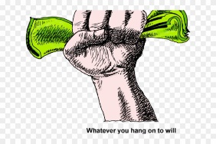 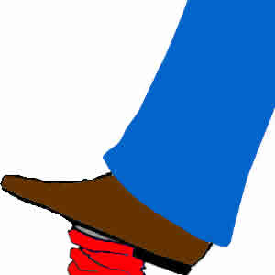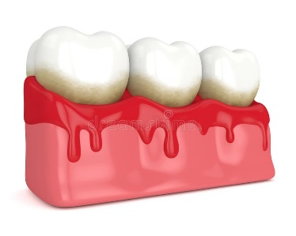

Thrill scrub slice grip crush gum

1. **Fill in the gaps with the correct words from the box.**

|  |
| --- |
| Scrub _Thrill _ Attack _ Stray _ Nibble _ Munch _ Nasty _ Yummy _ Defective _ Canines _ Molars _ Jaws _ Cavity _ Incisor _ Carnivores _ Herbivores _ Omnivores _ Prey _ Treat. |

1. Snails are a tasty treat for hedgehogs.
2. The lion stalked its prey through the long grass.
3. They are omnivores eating seeds, insects and snails.
4. They are herbivores and like lettuce, peas and spinach.
5. Lions and tigers are carnivores.
6. The third incisor in both upper and lower jaws is large.
7. There’s a cavity in the boy’s tooth.
8. The fish has strong jaws and sharp interlocking teeth.
9. The elephant grinds its food with its powerful molars.
10. Her two canines were larger than before and gave her the appearance of a vampire.
11. The building was destroyed when the **defective** boiler exploded.
12. This cake is really **yummy**.
13. He had a nasty moment when he thought he'd lost his passport.
14. We watched her munch her way through two packets of peanuts.
15. Instead of snacking on crisps and chocolate, nibble on celery or carrot.
16. Tourists often get lost and stray into dangerous areas.
17. They decided to attack their enemy's southern side.
18. His songs continues to thrill the audience.
19. I started to scrub off the dirt.
20. **Find the synonyms of the following words in the crossword and write them down.**

|  |  |  |  |  |  |  |  |  |  |  |  |
| --- | --- | --- | --- | --- | --- | --- | --- | --- | --- | --- | --- |
| v | e | c | s | c | l | e | a | n | f | i | n |
| a | w | g | u | a | r | u | n | e | a | r | y |
| b | i | t | e | a | c | t | u | l | b | n | m |
| s | c | r | u | n | c | h | y | o | n | a | d |
| g | a | w | f | u | l | y | p | y | o | r | h |
| r | a | w | d | e | l | i | c | i | o | u | s |
| e | c | g | a | b | o | n | e | s | v | e | c |
| t | v | i | c | t | i | m | t | i | o | n | v |

1. Scrub clean 2. Scurry run
2. Nibble bite 4. Munch crunch
3. Nasty awful 6. Yummy delicious
4. Jaws bones 8. Prey victim

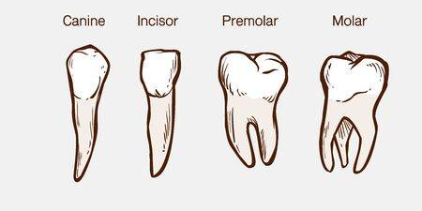

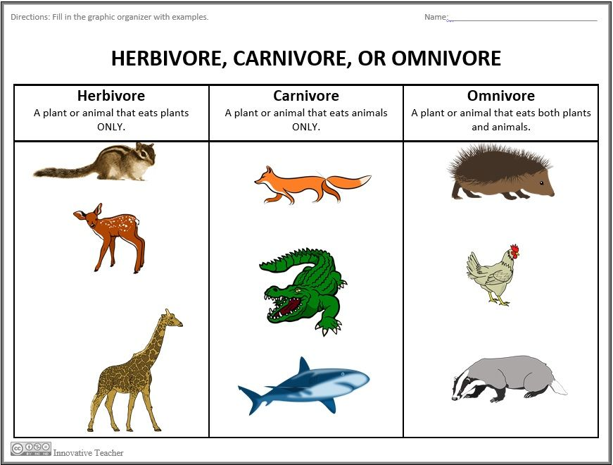

Teacher: Mirna Nawaf Al-Sahawneh.