

Worksheet (4) Unit Five

Present Continuous

Grade (4)

Name: Date: / /2022

|  |
| --- |
| **Objectives:**  1. To identify the present continuous tense.  2. To practice using the present continuous to talk about the actions that are happening at the moment of speaking. |

**Key Words :**

Now, at the moment , right now , today, Listen! , Look!, Be careful!, Be quiet .

**Present Continuous Form:**

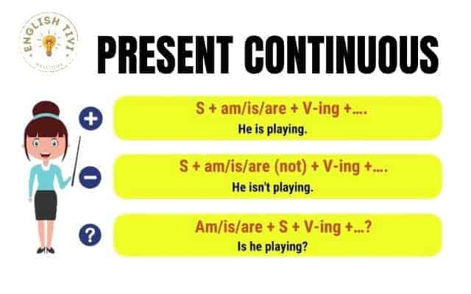

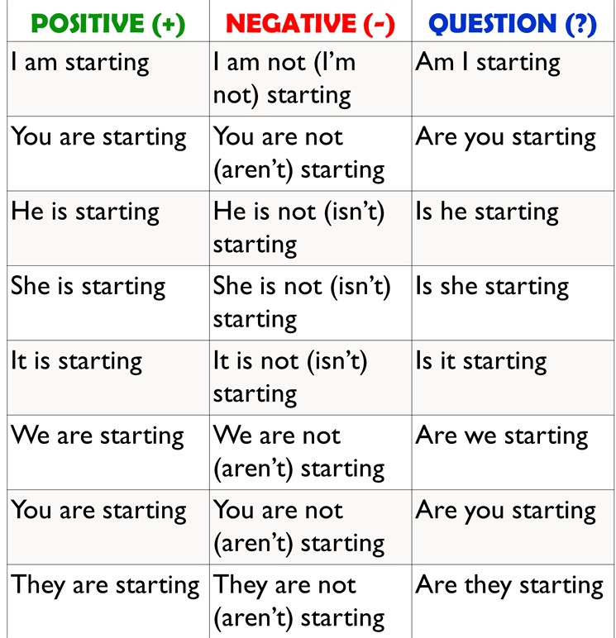

Writing rules :

1. Basic rule : just add **ing** to the verb .
2. Drop the letter **e** at the end of the verbs before adding **ing** .

Writ**e** + ing = writing Rid**e** + ing = riding

1. If the last letter is preceded by a vowel between two consonants. Double the last consonant before adding ing .

**Run** + ing = running S**wim** + ing = swimming .

Q1) 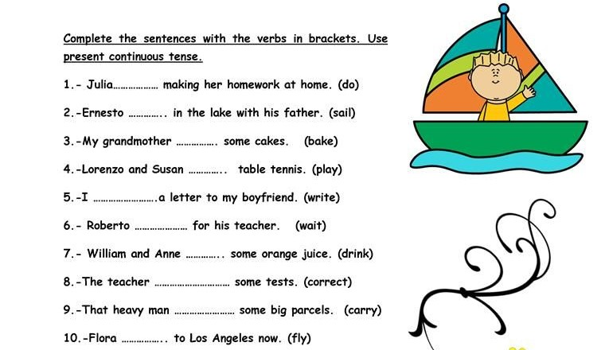

**Q2) Rewrite these sentences in the present continuous tense.**

1. I eat my favorite meal.

**I am eating my favorite meal.**

1. Be quiet! We learn English.

**Be quiet! We are learning English.**

1. He watches TV in the living room .

**He is watching TV in the living room.**

**Q3) Change these sentences into question and negative sentence .**

**Ex**: We are visiting my friend today.

**Negative** : We aren’t visiting my friend today .

**Question** :Are they visiting my friend today ?

1. She is going to the mall now .

Negative :**She isn’t going to the mall now.**

Question**: Is she going to the mall now?**

1. I am writing a story at this moment .

Negative: **I am not writing a story at this moment.**

Question: **Are you writing a story at this moment ?**

1. Look! The cat is dancing .

Negative: **Look ! The cat isn’t dancing.**

Question: **Is the cat dancing ?**

1. Listen! Somebody is playing the violin.

Negative: **Listen! Somebody isn’t playing the violin.**

Question: **Listen! Is somebody playing the violin?**

Q4) Answer these questions , use present continuous tense.

1. Are you wearing something red today ?

Yes, I am / No , I am not.

1. Is your teacher writing on the board now ?

Yes, she is / No , she isn’t .

1. Are your friends eating their breakfast ?

Yes, they are / No, they aren’t.

1. What are you doing at the moment ?

I, am studying my English exam.

Teacher : Raneem Haddad

Coordinator’s Signature : _________________.