***The importance of Islamic achievements in history***



***Jabir ibn Hayyan* (born 722 CE, died 815 CE)**

The Arab world has many famous chemists in its history, but the person who is known as the founder of chemistry is probably Jabir ibn Hayyan. He is most well-known for the beginning of the production of sulphuric acid. He also built a set of scales which changed the way in which chemists weighed items in a laboratory: his scales could weigh items over 6,000 times smaller than a kilogram.

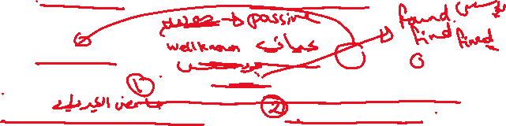

***Ali ibn Nafi’ (Ziryab)*  (born 789 CE, died 857 CE)**



`Ali ibn Nafi ’ is also known as ‘Ziryab’ (or ‘Blackbird’, because of his beautiful voice). He was a gifted pupil of a famous musician from Baghdad, and it was his talent for music that led him to Cordoba in the ninth century CE. He was the guest of the Umayyad ruler there. He is the person who established the first music school in the world in Cordoba, Al-Andalus, teaching musical harmony and composition. He revolutionized musical theory and is also the person who introduced the oud to Europe.



***Fatima al-Fihri***

**(born early 9th** **century,** **died 880 CE)**

Fatima al-Fihri was the daughter of a wealthy businessman. She used her father’s inheritance to build a learning centre in Fez, Morocco. This learning centre became Morocco’s top university, and it is where many students from all over the world come to study. Moreover, it was Fatima’s sister, Mariam who supervised the building of the Andalus Mosque, which was not far from the learning centre.



***Al-Kindi* (born around801 CE, died 873 CE)**



Al-Kindi was a physician, philosopher, mathematician, chemist, musician and astronomer– a true polymath. He made ground-breaking discoveries in many of these fields, but it is probably his work in arithmetic and geometry that has made him most famous.

