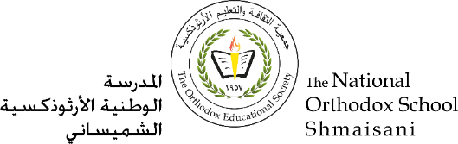

**The Primary Stage of Grades (4-5)**

**School Year 2022 - 2023**

**Name: ___________ Subject: English Language**

**Vocabulary Sheet #2**

**Date: / / Class: Grade 4 CP (All Sections)**

**____________________________________________________________________**

Objective/s: To use the following words correctly in writing.

|  |
| --- |
| **well known destination attraction historical tradition culture government original continents population** |

**1. Fill in the spaces with the correct word from the box:**

1. It's the good [weather](https://dictionary.cambridge.org/dictionary/english/weather) that makes Spain such a popular tourist destination.
2. 10% of the population were [living](https://dictionary.cambridge.org/dictionary/english/living) in [poverty](https://dictionary.cambridge.org/dictionary/english/poverty).
3. The continents make up about 35% of the earth's [crust](https://dictionary.cambridge.org/dictionary/english/crust).
4. She's [studying](https://dictionary.cambridge.org/dictionary/english/study) [modern](https://dictionary.cambridge.org/dictionary/english/modern) [Japanese](https://dictionary.cambridge.org/dictionary/english/japanese) [language](https://dictionary.cambridge.org/dictionary/english/language) and culture.
5. Many [important](https://dictionary.cambridge.org/dictionary/english/important) historical [documents](https://dictionary.cambridge.org/dictionary/english/document) were [destroyed](https://dictionary.cambridge.org/dictionary/english/destroy) when the [library](https://dictionary.cambridge.org/dictionary/english/library) was [bombed](https://dictionary.cambridge.org/dictionary/english/bombed).
6. He was unable to identify the original name of the site.
7. The government is spending millions of dollars to save the endangered animals.
8. He is a well- known local artist.
9. Fireworks have [long](https://dictionary.cambridge.org/dictionary/english/long) been an American tradition on the Fourth of [July](https://dictionary.cambridge.org/dictionary/english/july).
10. The waterfall continues to be the main attraction at the park.

**2.** **Use the following words in meaningful sentences.**

Original: Is this the original drawing or a copy?

Tradition: It is a [western](https://dictionary.cambridge.org/dictionary/english/western) tradition for brides to wear white.

Culture: We studied about the culture and history of London.

https://quizlet.com/744982443/4cp-unit-2-vocabulay-new-flash-cards/?new