

**Scratch-3**

**Classwork #1**

Name: Date:

1st Semester 2022 - 2023

**Objective: Check program for errors (*Chapter#3 – 3.3*)**

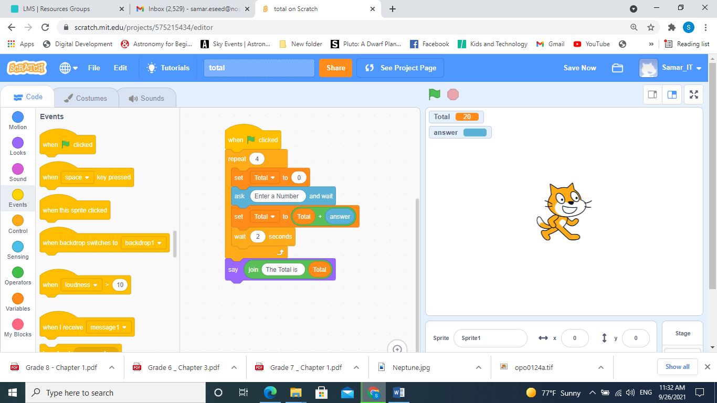**Q1- The following image shows a scratch program that can be used to calculate and display the total of 4 numbers.**

**This program includes an error.**

1. **Identify the error in the program.**
2. **Correct the error.**
3. **If we remove the wait block, does it affect the program.**

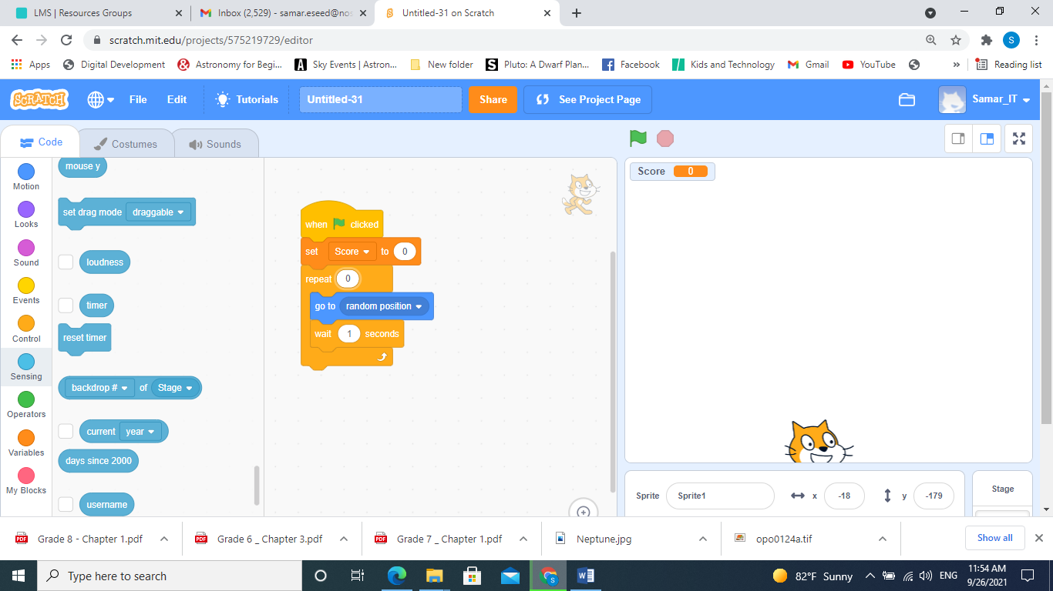**Q2- Explain what will happen when you click the green flag.**

1. **This program includes an error. Identify the error in the program, and correct this error.**