

**Scratch-3**

**Classwork #1**

Name: Date:

1st Semester 2022 - 2023

**Objective: Check program for errors (*Chapter#3 – 3.3*)**

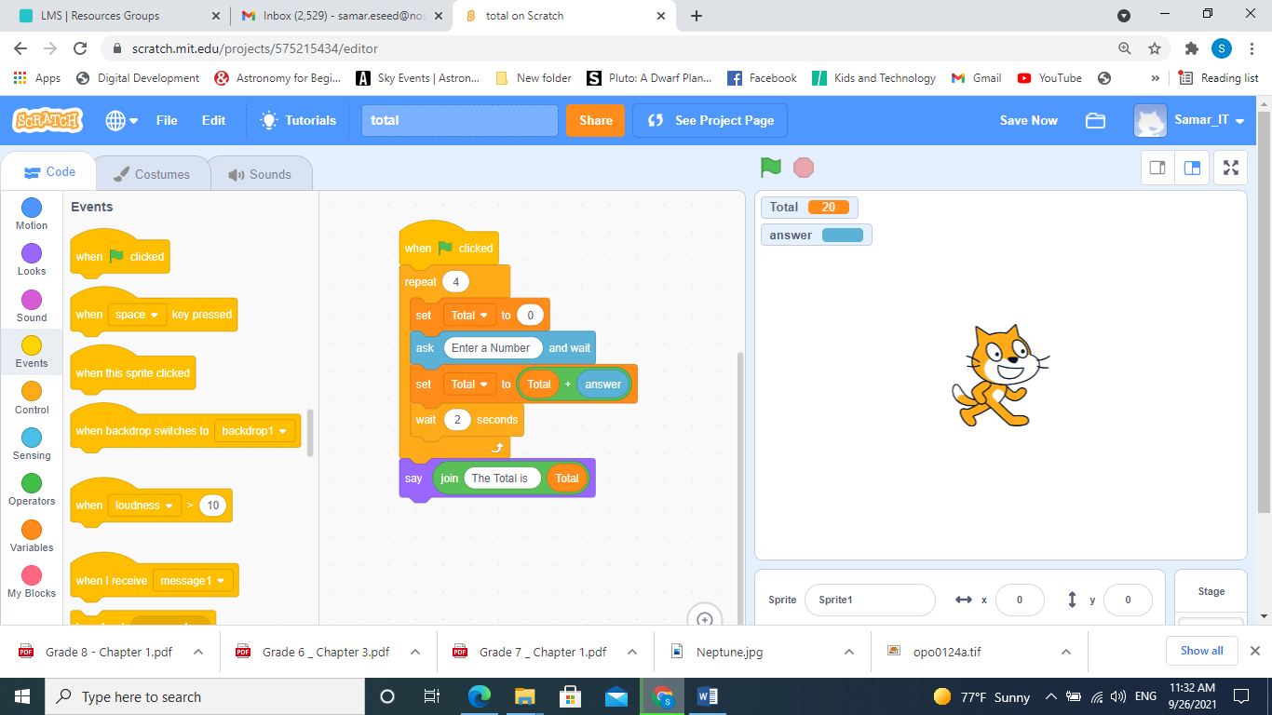**Q1- The following image shows a scratch program that can be used to calculate and display the total of 4 numbers.**

**This program includes an error.**

1. **Identify the error in the program.**

*The block [Set Total to 0]*

*is within the Repeat.*

1. **Correct the error.**

Move *The block [Set Total to 0] directly*

*after the block [When flag clicked]. before the Repeat*

1. **If we remove the wait block, does it affect the program.**

Yes – It will repeat the blocks faster.

**Q2-**

1. **Explain what will happen when you click the green flag.**

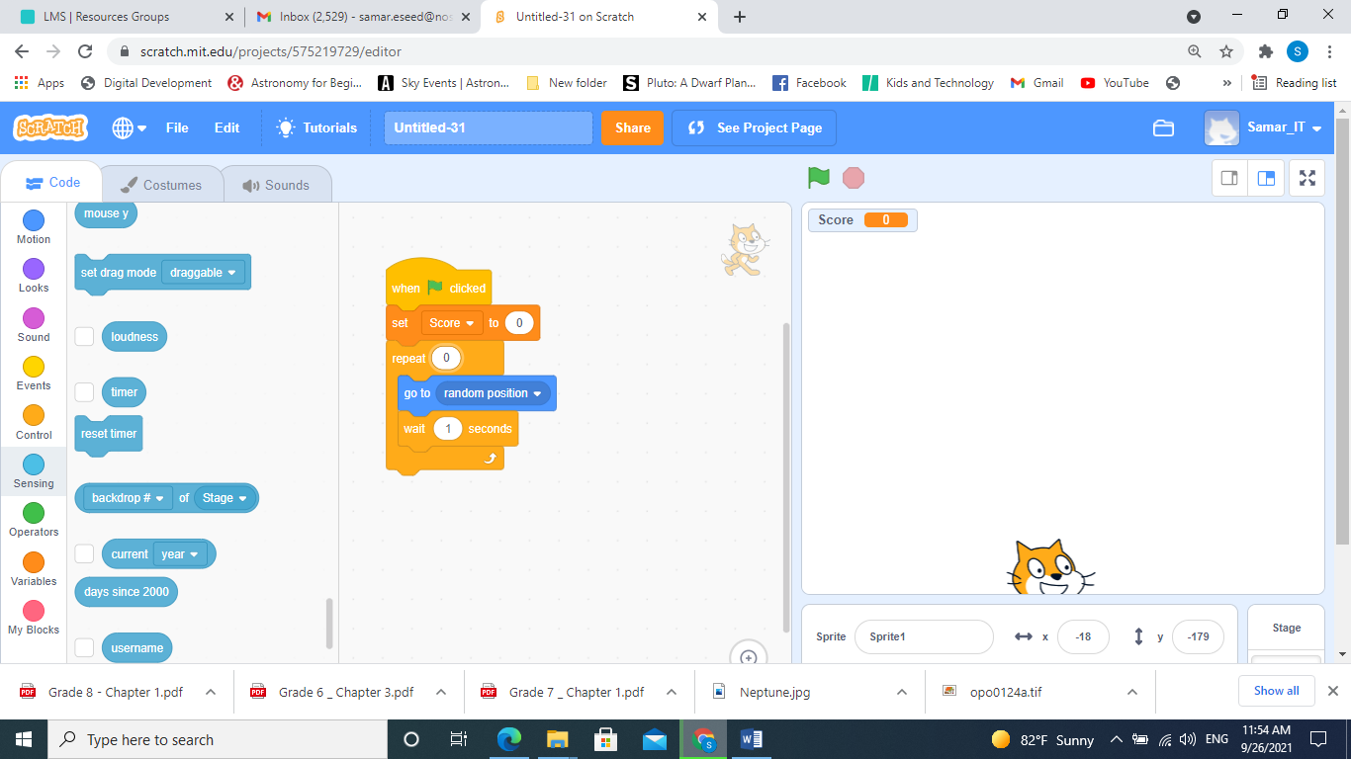Nothing will happen, the sprite will stay in its

original position

.

1. **This program includes an error. Identify the error in the program, and correct this error.**

Error: Repeat 0 is not correct

How to correct: add a number larger than 1 in the repeat block.

**Notes:**

Using [*Repeat 0*] is useless because nothing will be done.

Using [*Repeat 1*] is useless because the code will be repeated once.