

**Our value: Self – belief and hard work will always earn you success**

**Used to No (11)**

Grade 7 (A + B)

Name: ___________ Date: / /

Objectives: To use ‘’used to’’ to talk about habits or repeated actions in the past.

To practise using used to correctly.

**Used to**

Form: used to + infinitive.

We use this expression to talk about **habits or repeated actions in the past** which we **don't do** in the present. We also use it to talk about **states in the past** which are no longer **true.** For example:

* I **used to have** long hair. (but now I have short hair).
* He **used to smoke** (but now he doesn't smoke).
* They **used to live** in India (but now they live in Germany).

Watch out! With the negative and the question it's 'use' and not 'used'

* Did you **use to be** a teacher?
* Did he **use to study** French?
* She didn't **use to like** chocolate, but she does now.
* I didn't **use to want** to have a nice house.

Note! With this 'used to' there is no verb 'be'. We CAN'T say

~~“I’m used to have a long hair”~~

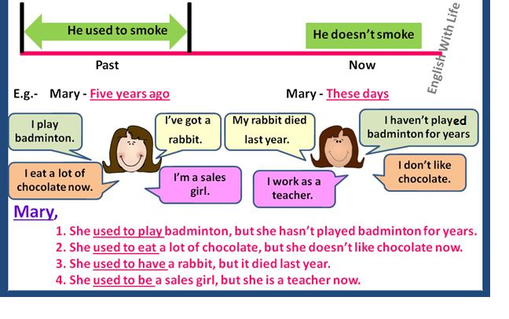

**Q1. Make an affirmative sentence, negative sentence or question using ‘used to:**

1) I / live in a flat when I was a child.

I used to live in a flat when I was a child

2) We / go to the beach every summer?

Did we use to go to the beach every summer?

3) She / love eating chocolate, but now she hates it.

She used to love eating chocolate, but now she hates it.

4) He / not / smoke.

He didn’t use to smoke.

5) I / play tennis when I was at school.

I used to play tennis when I was at school.

6) She / be able to speak French, but she has forgotten it all.

She used to be able to speak French, but she has forgotten it all.

7) He / play golf every weekend?

Did he use to play golf every weekend?

8) They both / have short hair.

They both used to have short hair.

9) Julie / study Portuguese.

Julie used to study Portuguese.

10) I / not / hate school.

I didn’t use to hate school.

Q2) Choose the correct words to complete each sentence.

1. Why did people _______________ mend their clothes?

**a) used to b) use to c) didn’t use to**

2. I _______________ like watching football, but now I do.

**a) used to b) use to c) didn’t use to**

3. What did you _______________ like doing when you were young?

**a) used to b) use to c) didn’t use to**

4. John _______________ like Mary, but he doesn’t now.

**a) used to b) use to c) didn’t use to**

5. People _______________ produce as much rubbish as we do nowadays.

**a) used to b) use to c) didn’t use to**

6. Did you _______________ collect anything when you were young?

**a) used to b) use to c) didn’t use to**

Q3) Complete these sentences with **used to or didn’t use to**.

1. I didn’t use to play the guitar, but I do now.

2. I used to ride a bike, but I don’t any more.

3. I used to collect stamps, but I don’t any more.

4. I didn’t use to enjoy getting up early, but I do now.

5. I didn’t use to be worried about the environment, but I am now.

6. I used to be afraid of flying, but I’m not anymore.

7. I didn’t use to know how to use a

computer, but I do now.

Teacher: Mirna Nawaf Al- Sahawneh.

Coordinator’s Signature: ------------------