|  |  |
| --- | --- |
| Discussing  *Advantages and disadvantages of  *Pros and cons of ……..  *The importance of ……………  *The necessity of …….  Suggest solutions- ways….. | Describing  *An event (holiday-after school)  *Something in the future(transport)  *Experiences and emotions  (First day at another school) |
| Introduction general statement  Thesis statement | Introduction  general statement+ Thesis statement+ personal view point |
| Body text ……………………… discussing both sides | Body text ………………………  Description  Prediction with will/rhetorical devices. (like /as/seem sound look) Adjectives |
| Conclusion………….  Summary/ your opinion | Conclusion………….  Summary- opinion |

**Free writing**

Discursive Essay Descriptive Essay



1. Online distance learning has been spreading among students in Jordan recently. Write an essay **discussing** the advantages and disadvantages of this method of learning.



1. Healthcare inventions have become more common worldwide. Write an essay describing how those inventions will help people who need them in the future, supporting your ideas with examples.
2. “He who has health has hope, and he who has hope has everything. Write a composition about the importance of an excellent healthcare system and how it contributes to a healthy community.

Title

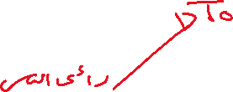

Is it true that _____________________? Have you ever wondered about this? For many people, it is believed that this topic sounds very interesting and remarkable to talk /discuss/handle about. Therefore, I intend to write_______________________________ .



Actually, there are a lot of **positive** points which are clear about this topic. First of all, ___on line learning **___ is** noticeably_______________ and___________________.Secondly, it is _____________________ and ___________________ .



For example, ___________________________.In addition to this, we should never forget that it might be fairly ___________________ and _____________________because _______________________. Finally, being _______________ and __________________ is obviously known. Of course, it has been very great to hear about this.



However, there are some disadvantages that are against____________ . I will start with the fact that it could be __________________ and ________________. Since it is ____________________. Moreover, it is known that it is___________ and __________________. Unexpectedly, it will cause many things, which include _____________________. That is why, we should carefully pay attention when tackling these points.



In the end, it is for those points, which have been considered impartially and comprehensibly, this topic deserves to be discussed. In my opinion, __________________ indeed made our life pleasant and convenient although it is impossible to forget its impacts that will certainly influence the way we live.

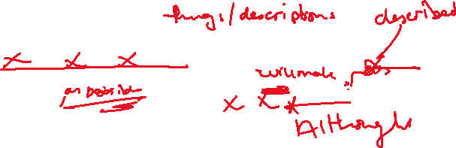

Introduction

