**Name: ______________________ Writing a Newspaper Report**

**Grade 6CS section:**

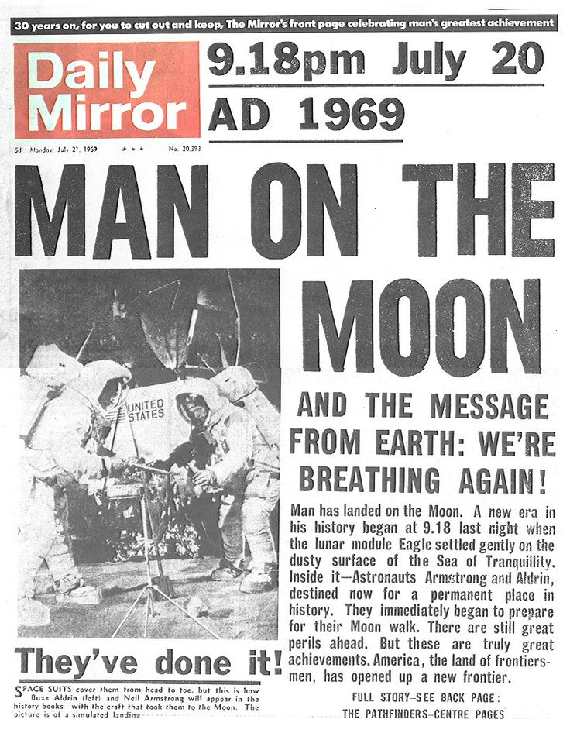



Writing a News Report

* The key elements of a News Report are:
  1. **Headline**



* + - Catches your attention
    - Sums up the story
  1. **Byline**
     + Writer’s name
     + Writer’s Specialty, e.g. sports, food, crime, current events
  2. **Lead**

4.

* The opening section
* Gives most important information
* Should answer most of the 5W's
  1. **Body**
     + Supplies detail
     + Most important details come first
     + Simple true statements
  2. **Quotation**
     + What someone actually said
     + Adds accuracy
     + Adds “at the scene” feeling

**News Report – An example**

**Headline**

**Car Thief Caught Trapped in Target Vehicle**

**Byline (name of author)**

Jim Day, Staff Reporter Wed Feb 25, 2009

**Lead**

* **catches reader interest,**
* **most important info**
* **introduces topic**
* **answers most of the 5W’s**

**Placeline**

CANBERRA - A bungling Australian car thief was nabbed after accidentally locking himself in the vehicle he was trying to steal, police said Wednesday.

Police were called to a house in Adelaide after two thieves were heard trying to steal a car. On arrival they were surprised to find a 53-year old man hiding inside the vehicle.

**Body**

**Quotation**

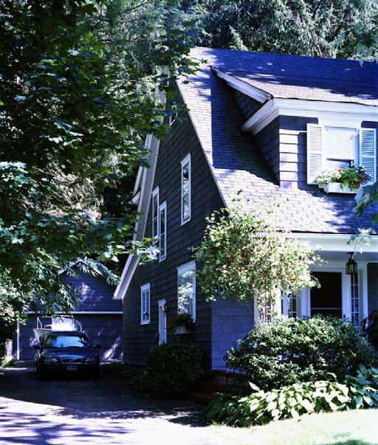"The man, while breaking into the car, had locked himself in the car and couldn't get out," South Australian police said, adding a second thief was found hiding in nearby bushes.

**Task:**

Write a **news report** based on the headline and picture below.

* You will have to make up the facts and information by answering some

or all of the following questions: Who? What? Where? When? Why? How?

* You must relate your newspaper report to **both** the headline **and** the picture.

**Purpose and**

**Audience:** to report on an event for the readers of a newspaper

**Length:**

The lined space provided for your written work indicates the approximate length of the writing expected.

**Before you submit your work:**

 Read your news report.

Answer the following questions as you read through the report!

|  |  |  |
| --- | --- | --- |
| YES | NO | Is the report related to the headline? |
| YES | NO | Are all 5 W’s present? |
| YES | NO | Is enough detail used? |
| YES | NO | Is there a quotation used? |
| YES | NO | Did you use third person narration? |
| YES | NO | Did you use proper spelling and grammar? |
| YES | NO | Is there a byline? |
| YES | NO | Is there a good lead paragraph? |

**Donation Day at NOS**

**_____________________________________________________________________________________________________________________________________________________________________________________________________________**

**Don’t wait to donate!**

**________________________________________________________________________________________________________________________________________________________________________________________________________________________________________________________________________________________________________________________________________________________________________________________________________________________________________________________________________________________________________________________________________________________________________________________________________________________________________________________________________________________________________________________________________________________________________________________________________________________________________________________________________________________________________________________________________________________________________________________________________________________________________________________________**