**Subject: Biology**

**Name:** **Worksheet: The carbon cycle**

**Date: Grade-Section**: 6 CS – all sections

**Question One:**

The diagram below shows the carbon cycle. Label the empty boxes with the correct process:

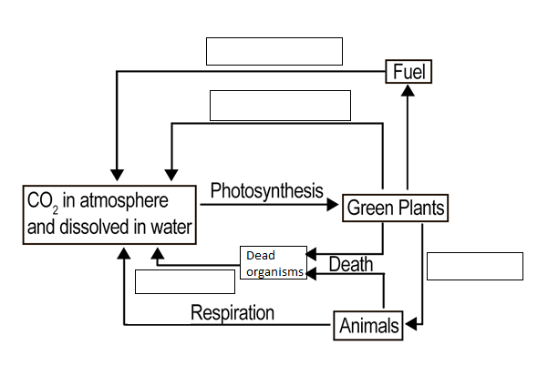

**Question Two:**

Use the words below to fill in the blanks.

Organisms dioxide carbon fungi decomposers respiration

The carbon cycle involves the cycling of __________ between the environment and ______________. photosynthesis and _______________ are the key processes involved in the cycle. Also decomposition which involves microorganisms called _____________ is important to digest waste and dead organisms. These microorganisms are bacteria and __________. These decomposers carry out respiration, which converts __________ compounds in dead and waste material back to carbon ___________ in the air.