**The National Orthodox School /Shmaisani**

**Subject: Chemistry**

**Name: Topic: The Periodic Table**

**Date: Grade-Section: 6CS- all sections**

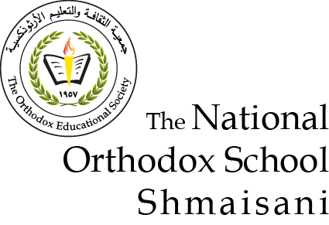

|  |  |  |
| --- | --- | --- |
| Write the names and symbols of 6 metals. | What is the name of group 7 and group 8 on the periodic table? | Write the names and symbols of 6 non-metals. |
| What is the element that is missing? | What are the vertical and horizontal lines in the periodic table called? | What is the element that is missing? |
| Can you find compounds on the periodic table? Explain why? | How are the elements in the periodic table arranged? | Some elements in the Periodic Table has symbols that don’t relate to their English name. Identify the word origins of two elements. |

**Name: Topic: The Periodic Table**

|  |  |  |
| --- | --- | --- |
|  |  |  |
|  |  |  |
|  |  |  |