**The National Orthodox School /Shmaisani**

**Subject: Chemistry**

**Name: Topic: The Periodic Table**

**Date: Grade-Section: 6CS- all sections**

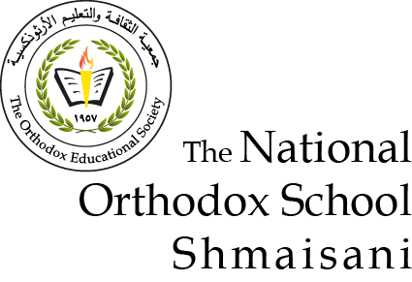

|  |  |  |
| --- | --- | --- |
| Lithium (Li)  Sodium (Na)  Potassium (K)  Magnesium (Mg)  Beryllium (Be)  Aluminum (Al) | group 7: Halogens  group 8: Noble gases | Fluorine (F)  Carbon (C)  Chlorine (Cl)  Iodine (I)  Neon (Ne)  Sulfur (S) |
| Oxygen (O) | Vertical lines: Groups    Horizontal lines: periods | Sodium (Na) |
| No, compounds and can be broken down into elements so they aren't included in the periodic table | The elements are arranged in order of increasing atomic number and elements in the same group have similar chemical properties. | Sodium (Na – Natrium)  Potassium (K – Kalium) |