** **

Name: ______________________

Grade: 6CS section: B, C, D, E, F

**Direct Speech and Reported Speech**

**Direct speech** is exactly what a person says. When we want to quote someone's exact words, we use quotation marks. For example:

* "The novel is really interesting," said Andrea.
* When we want to report what someone said, we do not use quotation marks. We report what they said, but we don't use their exact words. This is called **reported speech** or **indirect speech**.

For example:

* Andrea said the novel was really interesting.





**Changes in Person, Place, Time, and Possessive Pronouns**

When we use indirect speech, we are reporting what someone else said in a different time and situation. Logically, we need to change some of the words from the original statement.

This happens with person, place, time, and possessive words.

For example:

* DIRECT SPEECH: "**You** are a very good employee."  
  REPORTED SPEECH: He said **I** was a very good employee.  
  (We need to change the **person** word.)
* DIRECT SPEECH: "It is sunny **here**."  
  REPORTED SPEECH: She said it was sunny **there**.  
  (We need to change the **place** word.)
* 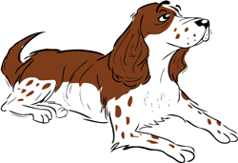DIRECT SPEECH: "I went to a concert **yesterday**."  
  REPORTED SPEECH: She said she went to a concert **the day before**.  
  (We need to change the **time** word.)
* DIRECT SPEECH: "Harvey is **our** pet dog."  
  REPORTED SPEECH: She said Harvey is **their** pet dog.  
  (We need to change the **possessive** word.)

**Reporting Verbs**

There are some verbs that we use very often when we report what other people said.

* say
* tell
* warn
* promise
* announce
* mention

**Remember** that when we use the reporting verbs **tell** and **warn**, we always need to say **who**.

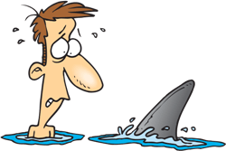**For example:**

* Emily **told** **me** she had finished her project.
* The lifeguard **warned** **the swimmers** there could be sharks.
* It is important to remember that the word **that** in reported speech is **almost always optional**.

**For example:**

* They said there was a meeting at four o'clock.  
  OR  
  They said **that** there was a meeting at four o'clock.

**Tense Shift**

When we report what someone else has said, we are giving the information **at a later time**. They said something earlier, and we are reporting it now.

Because we are giving the information at a later time, we need to change the tense in the original statement so that it makes sense. We "**back-step**" with the verb tense.

For example, if the statement was made in the simple present, we report it in the simple past:

* "I **am** really tired," she said.
* She said she **was** really tired.

**Reporting with Modal Verbs**

Some common modal verbs must be changed when we use reported speech.

For example:

* "I **will** be there by dinnertime," she promised.
* She promised she **would** be here by dinnertime.
* "Sam **can** play with you today," Mrs. Groban told me.
* Mrs. Groban told me Sam **could** play with me yesterday.
* "You **must** wear formal clothes to the event," the director said.
* The director said I **had to** wear formal clothes to the event.
* "We **may** see a movie later," Ellen said.
* Ellen said they **might** see a movie later.
* "We **shall** be quite tired when we finish," said Dan.
* Dan said they **would** be quite tired when they finished.

Now, let's get some practice!

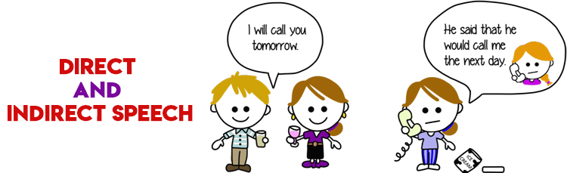

**Exercise 1:**

**Changes in Person, Place, Time, and Possessive Pronouns**



Fill in the blanks to correctly report what these people said.

1. "We are getting married this afternoon!"

They said they were getting married ________________ afternoon.

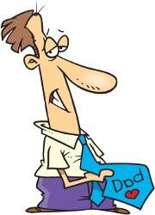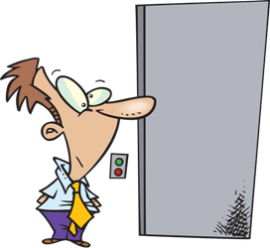

2. "You don't understand!"

He said _______________ didn't understand.

3. “I love the *Toy Story* films.”

She said _________________________ the *Toy Story* films.

4. “I will phone you tomorrow.”

He said ______________________________________________________________

**Exercise 2:**

**Tense Shift**

Complete the sentences for each picture using the correct tense shift.

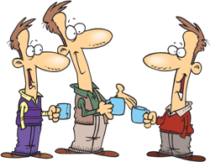

1. "They are chatting about work,” he said.

________________________________________________________.

2. "That man is trying to get away,” she said.

_________________________________________________________.

3. "I love everything about her,” he said.

___________________________________________________________.

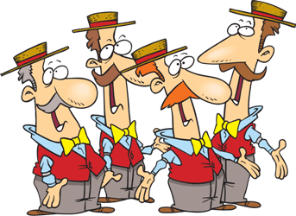4. "We sing together on every concert.” They said.

____________________________________________________________.

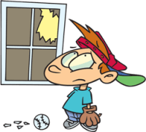5. "I work in a bank," Danielle said.

_____________________________________________________________.

**Exercise 4:**

**Reporting with Modal Verbs**

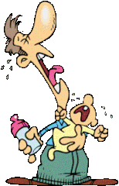

1. "We shall both need a nap!"

He said they ______________ both need a nap.

2. "I must finish this assignment!"

He said he ________________ finish that assignment.

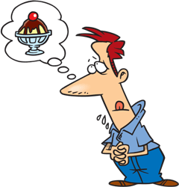3. "I may have some ice cream for dessert."

He said he _______________ have some ice cream for dessert.

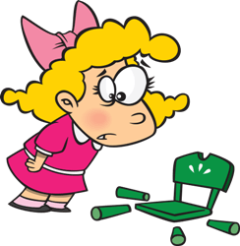

4. "I will fix it!"

She said she _______________ fix it.

5. "I can make a lot of money with this idea!"

He said he _______________ make a lot of money with his idea.

**Exercise 5:** Now try putting these direct speech sentences into indirect speech.

a. “I can’t afford those new trainers Sara!” explained dad.

…………………………………………………………………………………………………

b. “It’s raining heavily!” remarked Uncle John.

…………………………………………………………………………………………………

c. “I’m feeling terribly sick!” shouted Bob’s brother.

…………………………………………………………………………………………………

d. “I’ll be leaving tomorrow!” shouted the tenant.

…………………………………………………………………………………………………

e. “It’s a glorious day for a picnic!” said Grandma.

…………………………………………………………………………………………………

f. The mountaineer boasted, “I could easily climb that mountain!”

…………………………………………………………………………………………………

