

**The Primary Stage (4-5)**

**School Year 2022 - 2023**

**Name** : ___________ **Subject** : Writing worksheet # 3

**Date : / / Class : Grade 4 CP (All Sections)**

**_____________________________________________________________**

**Objective/s: to identify the features of a non-chronological report.**

**To write a non-chronological report.**

**Non-Chronological Report**

We write non-chronological reports to give people information on a particular subject. A non-chronological report is non-fiction.

**Structure**

• Use a title.

• Write an introduction.

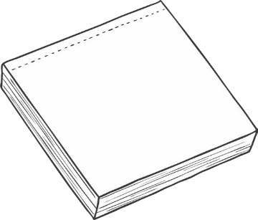

• Put your information into sections (paragraphs).

• Use sub-headings to organise your writing.

• Use facts that you have researched.

• Include pictures with captions or labels.

• Include short, interesting facts to grab the reader’s attention.

**Language Features**

• Use technical language relating to the subject.

• Write in present tense.

• Write in third person.

**Directions:** Research a country or a city you would like to visit. Make notes about the features of the country or city you have chosen, such as various places to visit, transportation, language spoken, and food. Write a list of the specific vocabulary you will use under these headings.

Write your report here.

Paris

Paris is the capital city of France, with the largest population in the country. People who live there are called Parisians. Paris is one of the world’s leading cities in the fashion, music, politics and the arts.

**Landmarks**

There are many famous landmarks worth visiting in Paris. The Eiffel Tower was built in 1889 for the Paris World’s Fair and has stood for over 100 years. Nearby is the Louvre, which is the biggest museum in the world. It contains many artefacts and paintings including Leonardo da Vinci’s Mona Lisa. Notre Dame cathedral is another well- known tourist attraction located in the very heart of Paris. Not to mention The Arc de Triomphe which honours those who fought in past battles.

**Disneyland**

Disneyland Paris opened on 12th April 1992. It was originally called ‘Euro Disney’ and was the second resort to open outside of the US. It has two theme parks, seven Disney themed hotels, shops, a cinema and is Europe’s leading tourist destination!

**Food**

Paris is famous for its elegant pastries and cheeses. A typical Parisian meal can consist of a starter, introductory course like soup, a main course and dessert cheese or dessert.

Paris is visited by many tourists every year, it is an excellent destination.

|  |  |
| --- | --- |
| Content, purpose and audience | /5 |
| Text structure and organization | /4 |
| Sentence structure and punctuation | /4 |
| Spelling | /2 |
| Total | /15 |

