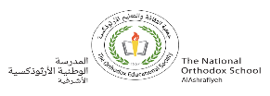**Unit 2 / Synonyms No (8)**

**Our value: Self – belief and hard work will always earn you success**

**Name………………… Grade 5 (A+B)**

Objectives: To learn what a synonym is.

To learn the synonyms of nouns and adjectives and practise using them.

**Synonyms**

A synonym is a word or phrase that means the same (or very nearly the same) as another word or phrase. Words that are synonyms are described as *synonymous*.

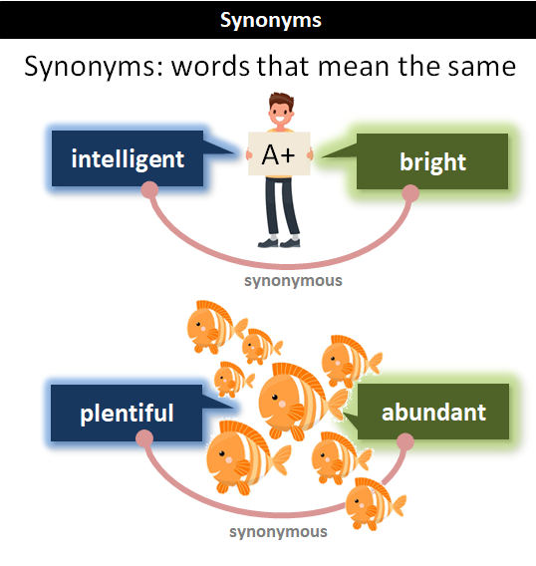

***\*\* Here are more examples (adjectives):***

Afraid, scared, frightened 

Big, large, huge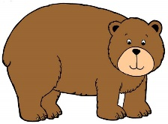

Blank, empty, hollow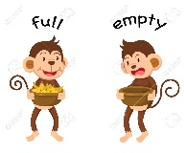

Quick, fast, swift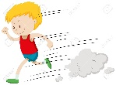

Famous, well-known

Funny, silly, playful, crazy

Neat, tidy, clean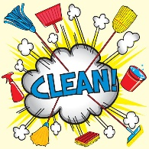

Strange, odd, weird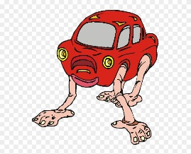

Quiet, calm

Gloomy, sad, unhappy

Happy, glad, joyful, cheerful

Mad, angry, furious 

Little, small, tiny 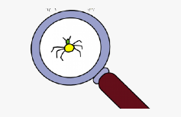

Ill, sick, unwell 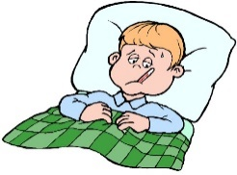

**Beautiful,** attractive, pretty, lovely, stunning 

***\*\* Here are more examples (nouns):***

Bunny, rabbit, hare 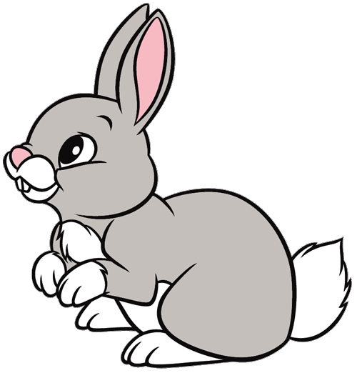

Cap, hat 

Couch, sofa

Garbage, trash, junk, waste 

Present, gift, reward, award 

Mother, mom, mommy 

House, home 

Rock, stone 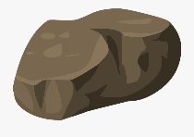

Rug, carpet, mat 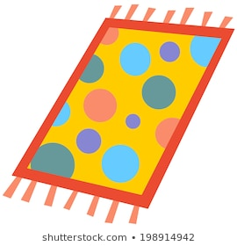

Sack, bag, backpack 

Woman, lady, female 

***Practice***

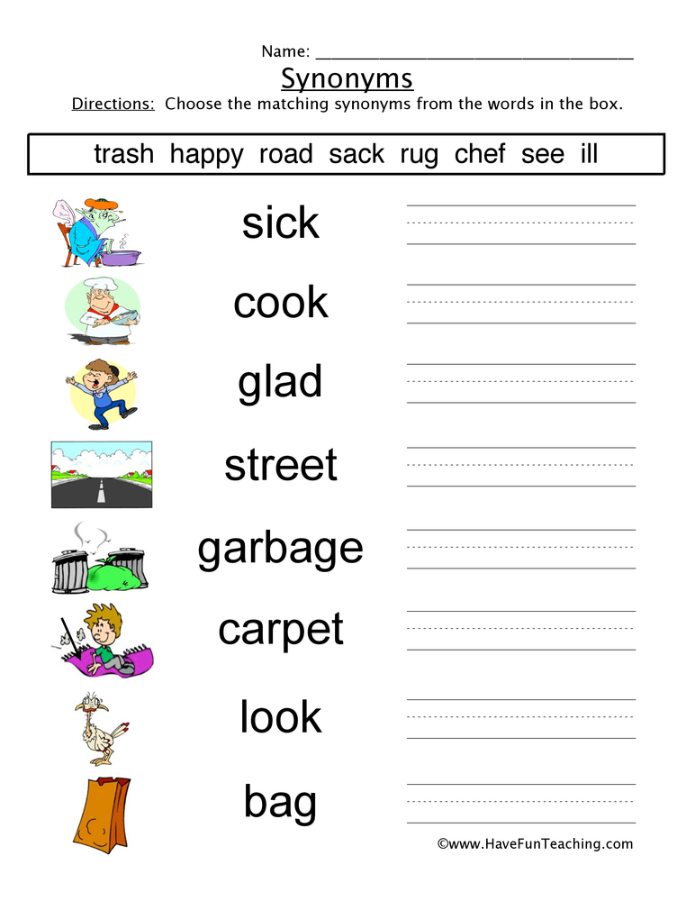

sack

see

rug

trash

road

chef

happy

ill

*Teacher: Mirna Nawaf Al-Sahawneh.*

*Coordinator’s Signature: ----------------*