Describing an animal using the present simple tense.

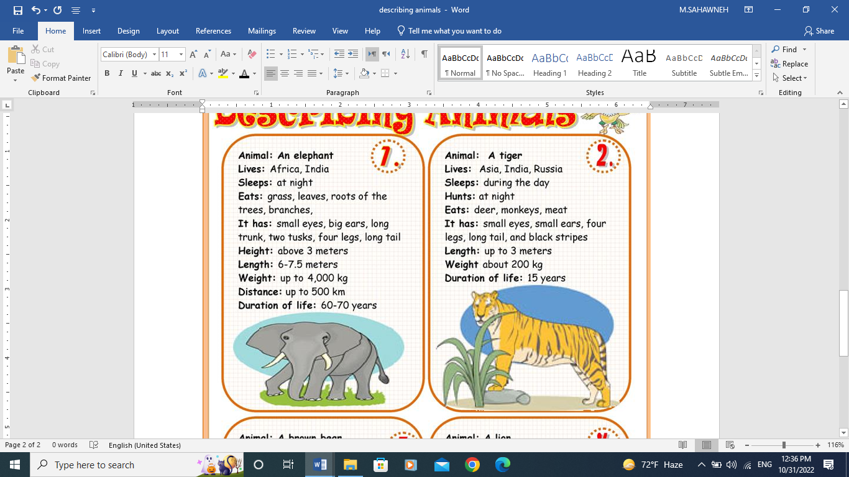

A tiger is an animal that lives in Asia, India and Russia. It sleeps during the day. It hunts at night. It eats deer, monkeys and meat. It has small eyes, small ears, four legs, long tail and black stripes. It is up to 3 meters long. It weighs about 200 kg. It can live for 15 years.