**Name: Worksheet(3) Grade:6(A(**

**Subject : Math Date :**



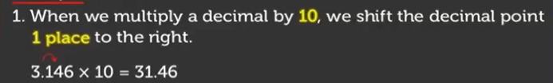

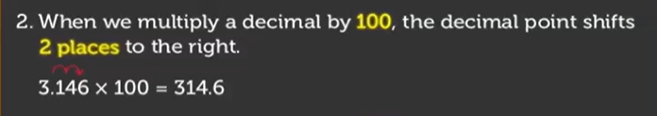

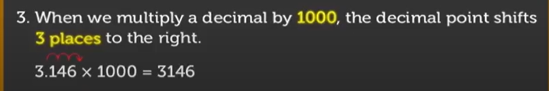

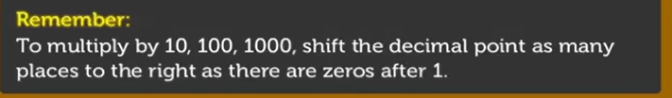



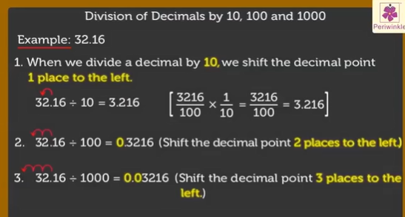

**_________________________________________________________**

**_________________________________________________________**

**_____________________________________________________**

**______________________________________________________**

**________________________________________________________**

**_______________________________________________________**

**8) $7.8÷100=$**

**__________________________________________________________**

**9) $6.17÷1000=$**

$$10)8÷10=$$

$$11) 9÷100=$$

$$12) 354÷1000=$$

$$13) 7×100 ÷1000=$$

**__________________________________________________________**

**_____________________________________________________________**

**_______________________________________________________**

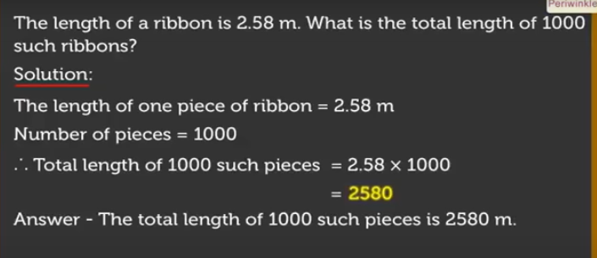

$$Exercise (2):$$

$$Exercise (3):$$

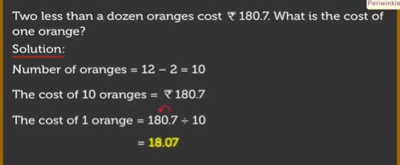

**Teacher : wisam al mashni**