
With awareness come responsibility and choice
Meaning Worksheet ( 2 )
Grade 2
Name: Date: / /2022
Objectives: To identify the meaning of new words.
To practise using the new words in sentences.
- Study the words below:
Word | Meaning
worm | 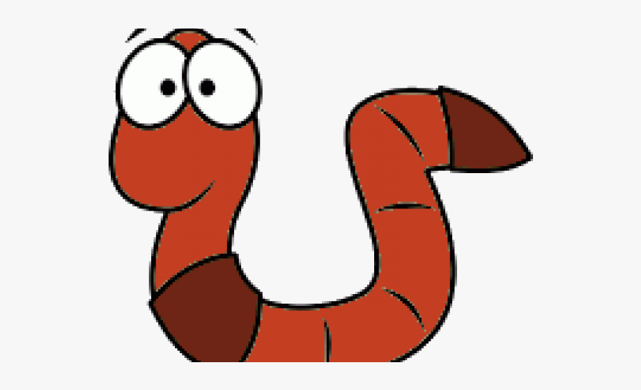
squawk | 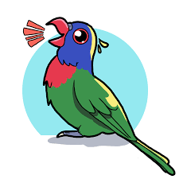
pinecone | 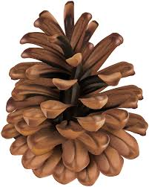
fight | 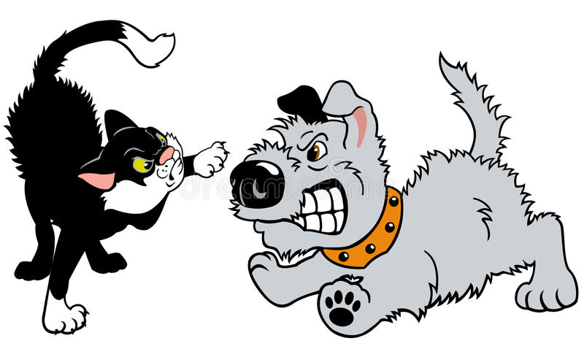
creep | 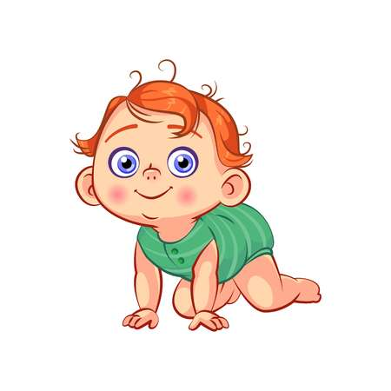
escape | 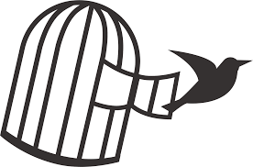
hunt | 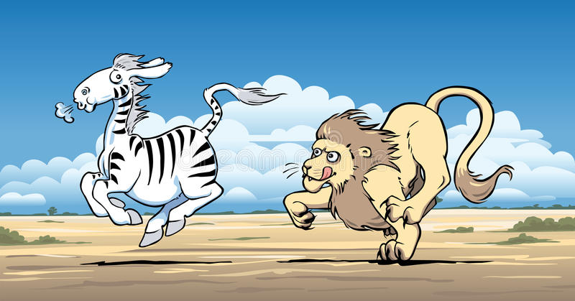
peck | 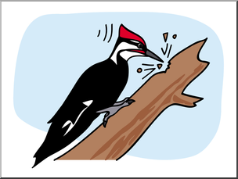
berries | 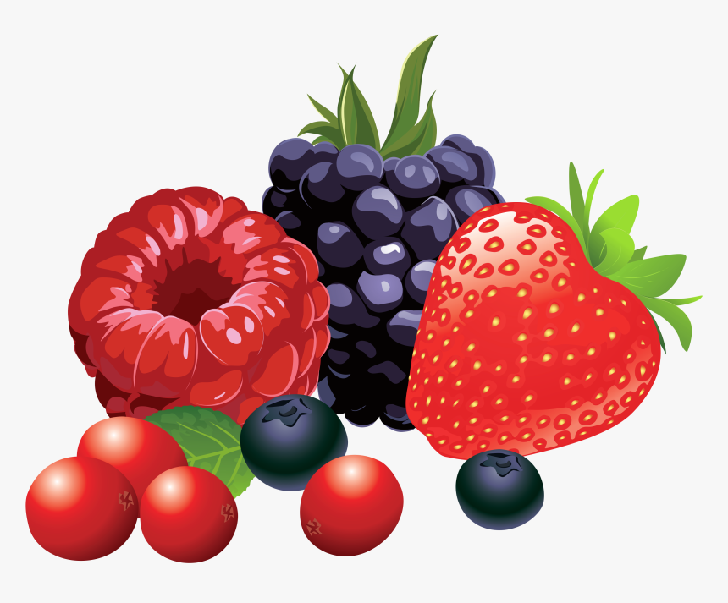

2) Circle the correct word:
Peck- fight -hunt

escape – berries- worm
pinecone- squawk-fight

3)Fill in the blanks with the correct word:
creep hunt Pinecones peck worm

- Pinecones grow on pine trees.
- Wild animals hunt for food .
- Birds peck seeds on the ground.
- The snake creep quietly in the grass.
- A _wormlives under the ground.

T.Taghreed Alnimri

