
With awareness come responsibility and choice.

Worksheet (8)
Grade 1)
Name: ------------ Date: /10 /2022
*Objectives: 1-To be able to identify naming words.
Nouns
*Words that names things are called nouns.
*A noun names a person ,place, thing or an animal.

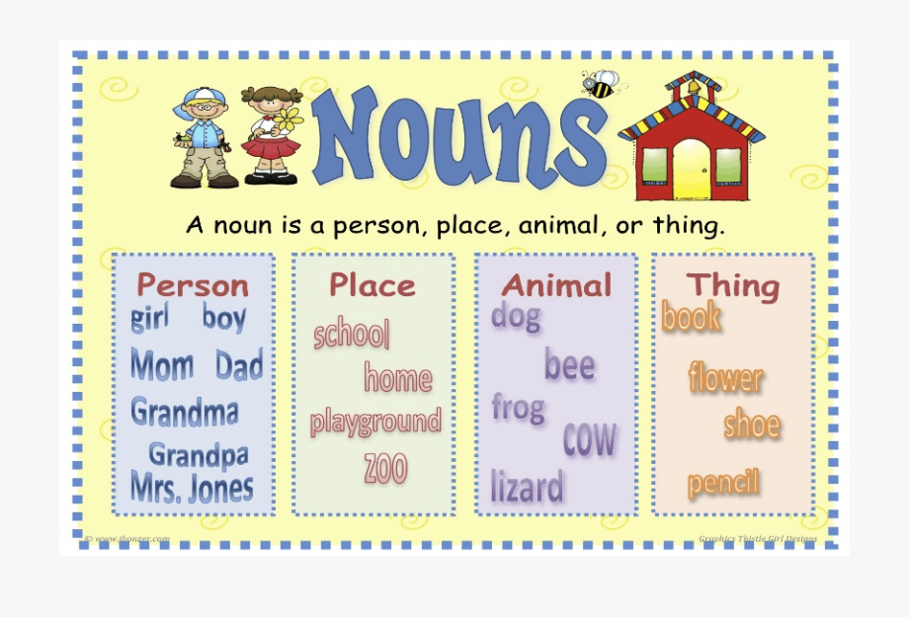

1-Look at each picture. Write a noun that names each person,place, thing or animal.
bb boy dog bag house

 dog



bag

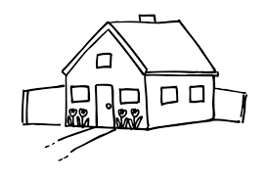
house

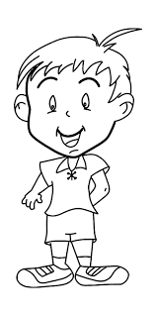

boy
T.Taghreed Alnimri Coordinator’s Signature:

