
With awareness come responsibility and choice
Meaning Worksheet ( 2 )
Grade 1
Name: Date: / /2022
Objectives: To identify the meaning of new words.
To practise using the new words in sentences.
- Study the words below:
Word | Meaning
elephant | 
tortoise | 
lonely | 
sad | 
scared | 
eat | 
play | 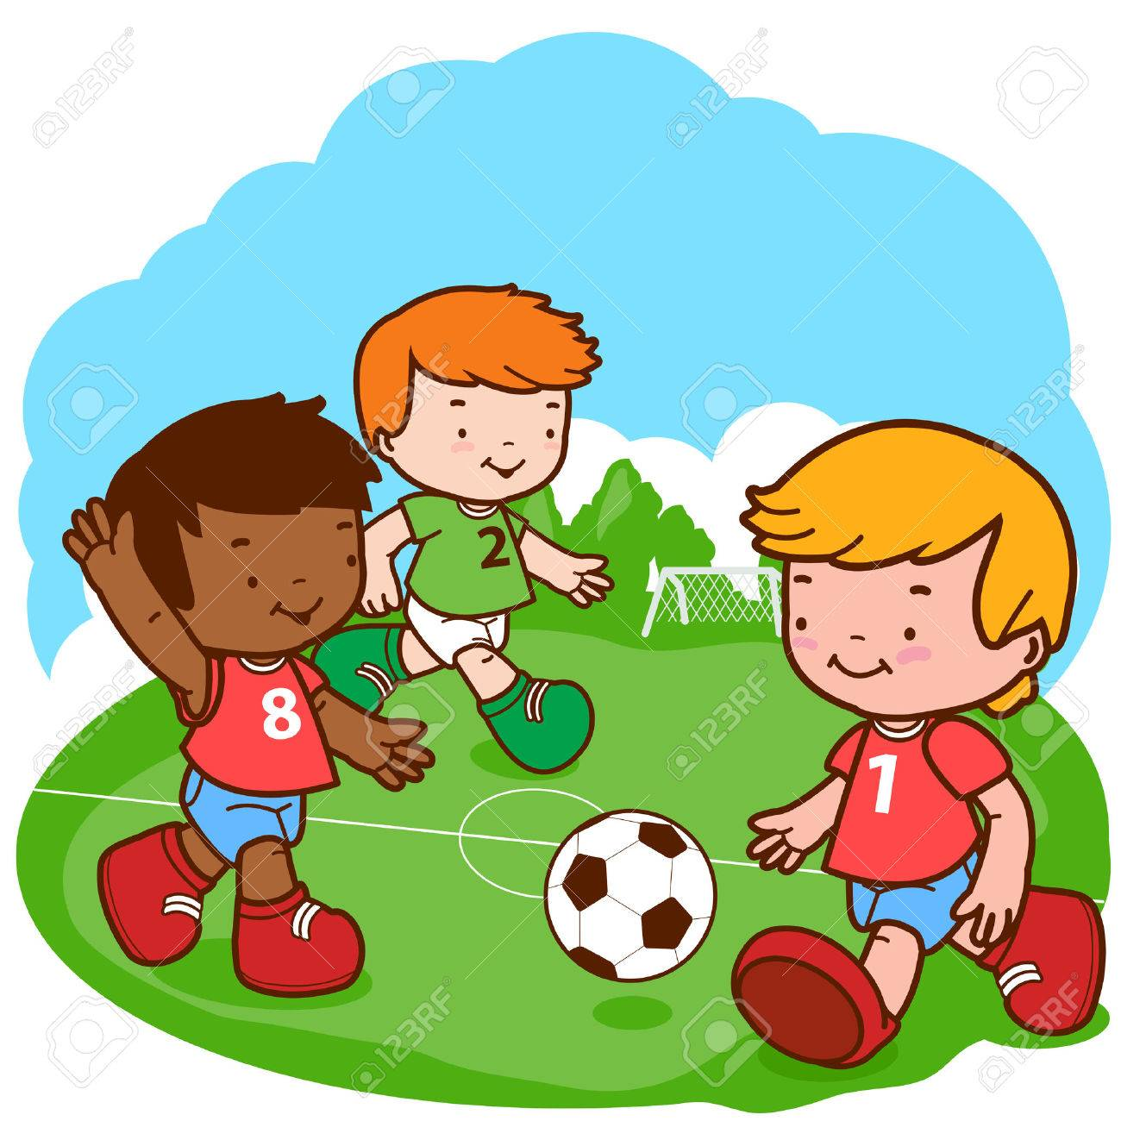
friends | 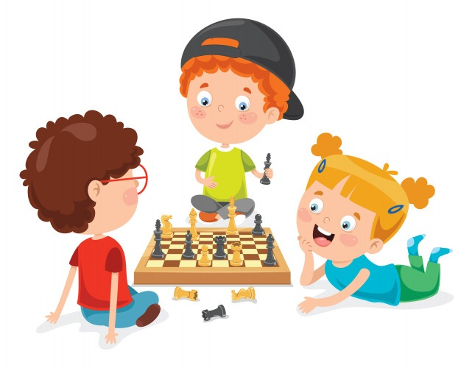
sleep | 

2) Circle the correct word:
sad –scared– play
play-eat-tortoise
lonely - elephant- friends

3)Fill in the blanks with the correct word:
play lonely eat scared

- Zaid is a lonely no one plays with him.
- My brother likes to eatfruits.
- I am scared of snakes.
- I like to play basketball.

T.Taghreed Alnimri

